University of Puerto Rico at Mayagüez
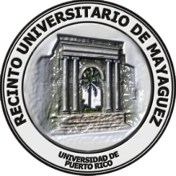
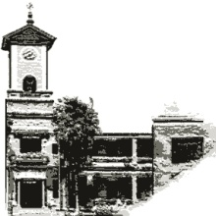
Continuous Improvement and Assessment Office

Students Learning Assessment Report for 2016-2017

Faculty _____________________________________ Department_____________________________________________

SECTION I: Mission and Student Learning Outcomes (Graduating Student Profile)
State the department’s mission and list the student learning outcomes (graduating student profile).

Mission

Student learning outcomes
SLA Report, cont.

SECTION II: Student Learning Assessment Results

Sub-section |  | Content description | Program assessment
Focus of Assessment Project |  | • What was assessed – a particular skill or content area, a course, or a learning outcome?  • How is it related to your department learning outcomes? Be specific.
Justification (data-based) |  | • What facts (e.g., student performance, faculty evaluations, pre-study) motivated the department/assessment committee to focus on the selected skill/content/outcome(s)?.
POPULATION  Student  Faculty |  | • What were the numbers of students and faculty members impacted by the project?  • Was the focus on all students or on a sub-group of students (e.g., second year students)?  • Are the students department majors?
Assessment  Cycle | Pre-intervention | • What measures or tools (e.g., pretest, critical thinking essay) were applied to determine the student status on the chosen skill or content before the intervention?  • Note: Pre-intervention may be the same as Justification (above)
 | Intervention | • What activities (e.g., workshop, lecture) were implemented to improve student performance in the chosen skill or content?
 | Post-intervention | • What are the criteria for success and how was the effectiveness of the intervention determined?  • What tools (e.g., post-test, post essay, exam) were used to determine student progress on the chosen skill or content?  • How were the tools applied and to whom?
Results |  | • What results were obtained? Indicate date of review.  • What do the results imply about the effectiveness of the intervention to improve student learning?  • Does performance differ by student group (e.g., gender)?
Dissemination of Results |  | • How, when, and to whom were the results of the assessment project disseminated?
Possible Reasons or Hypotheses |  | • What are possible explanations for the results, be they positive or negative, e.g., intervention was not effective to improve student performance?
Course of Action |  | • What actions have been or will be taken based on these results? Will the action require more assessment? Be explicit.
Next Assessment Priority |  | • What do you plan to assess next? Will you continue on this same item or assess a different skill or content?
Appendix |  | • Include copies of all assessment tools (unless distribution is restricted)

