Export Restriction Lookup Guide
In the process of exporting the government provides the user with various ways avoiding a problem with export regulators by providing various lists that allow a user to identify whether a person/entity have been placed in its restriction list. Using these lists the user would be able to identify if someone they’re working with in a research or someone that plans to receive a package you sent has an export restriction placed by the Federal government of the United States.
There are many lists that are found in various websites of various federal agencies however, there are four major lists that need to be checked before working with any foreign entity/national. The lists are as following:
- Denied Persons List- Regulated by the Bureau of Industry and Security (BIS)
- Specially Designated Nationals List- Regulated by the Office of Foreign Assets Control (OFAC)
- List of Statutorily Debarred Parties- Regulated by the Department of State
- Entity List- Regulated by the Federal Law 15CFR744
In this step by step guide the user can follow the directions and would easily be able to use the lists to identify if anyone that they are working with has an export restriction given by the United States.
- Denied Persons List (BIS)
https://www.bis.doc.gov/index.php/policy-guidance/lists-of-parties-of-concern/denied-persons-list
To begin the search on the Denied Persons List please click on the link above, by clicking the link it should take you to the following page below. 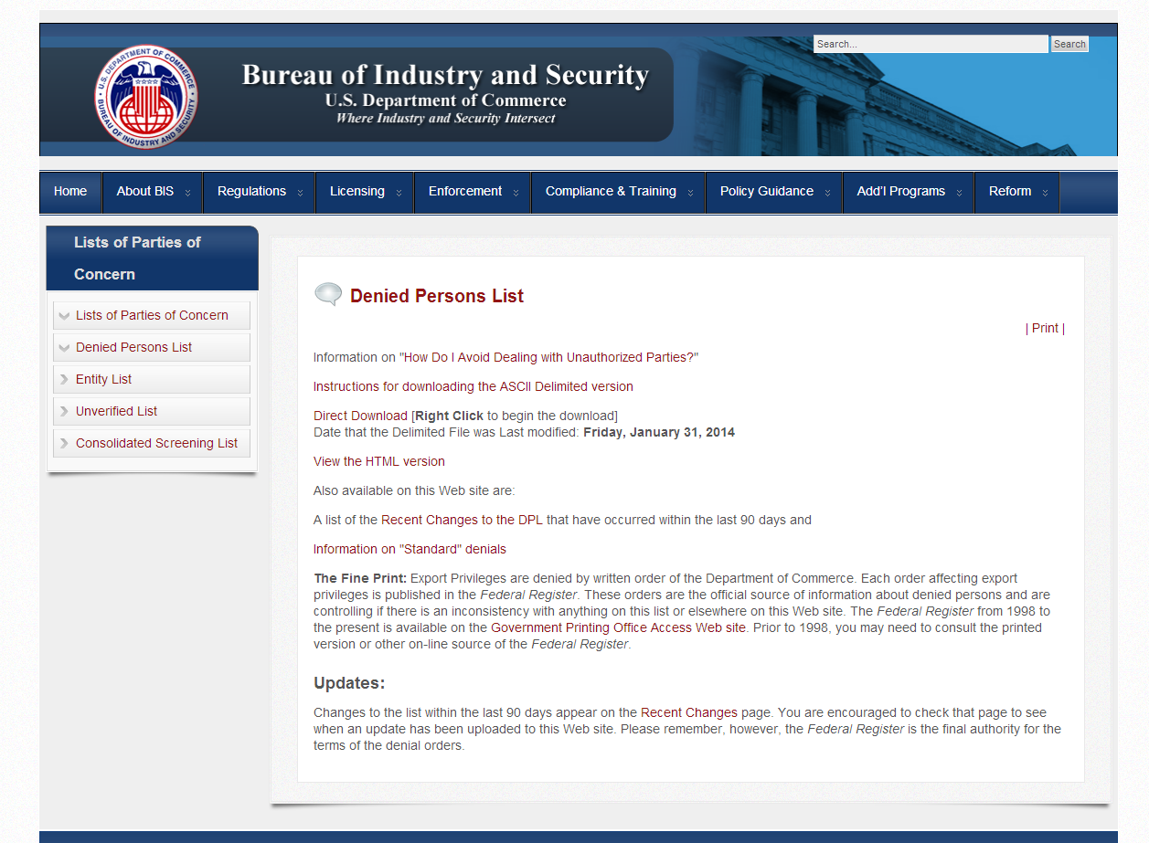
On this page you can see that there are various links regarding including the html version online however, the easiest way to conduct the search is by directly downloading the file and copying it to Microsoft Excel. The whole process should not take more then a couple of minutes.

- First go to the link that says “Direct Download”
- On that link press the “right click” on your mouse. When you do this various options will come up on the screen. The option that you want to choose is the “Save as” option. After clicking that option save the file to your computer.
- After saving the file open the saved file and a Microsoft Excel spreadsheet. With both files open go to file with the list information select and copy all of the data. After copying the data go to the Microsoft Excel spreadsheet and paste the data.
- By following the various steps listed the information that was found in txt file will be placed automatically in an orderly fashion in the spreadsheet. The spreadsheet should look like the one below.
- In the spreadsheet a user can easily search the list by using the Find function (Ctrl F) in the spreadsheet.
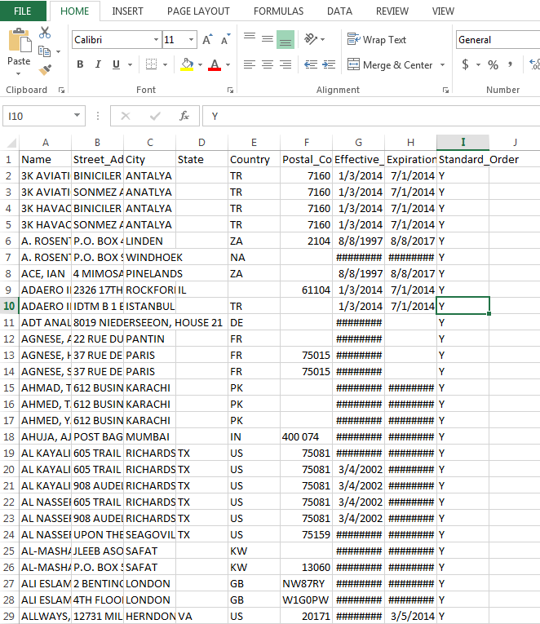

- Specially Designated Nationals List-(OFAC)

http://www.treasury.gov/resource-center/sanctions/SDN-List/Pages/default.aspx

To begin searching on the Specially Designated list please click on the link above. Once the link is opened the page below should be the one that is displayed.
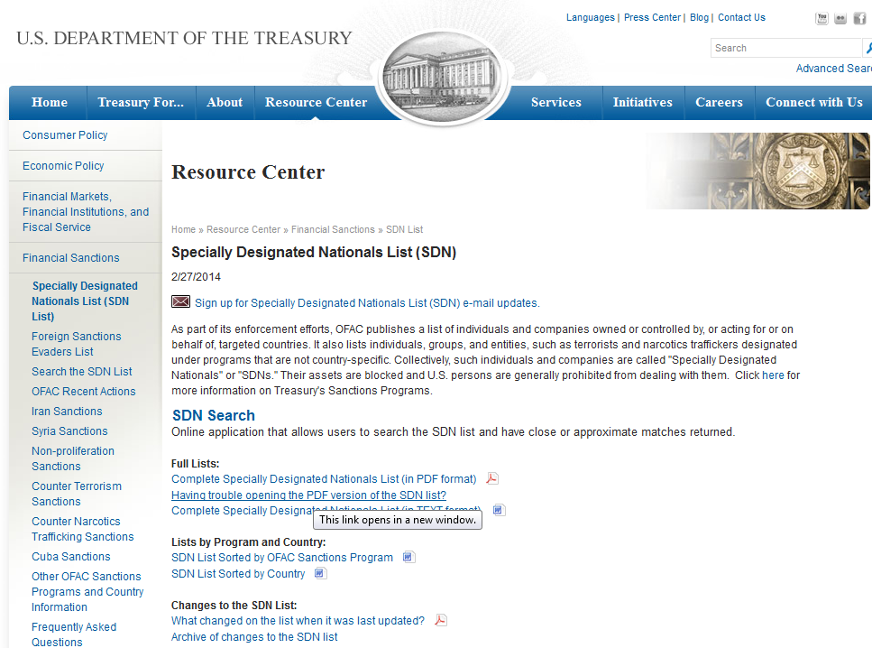

In this website the Department of Treasury provides different ways for a user to download the information to begin to search the list. In this site it is up to the user on which way they would prefer to search the information. However, in our experience the list in the PDF format has been sufficient.

- List of Statutorily Debarred Parties (Dept. of State)

http://pmddtc.state.gov/compliance/debar.html

To use the List of Statutorily Debarred Parties please click on the link above, by clicking the link it should take you to the following page below.

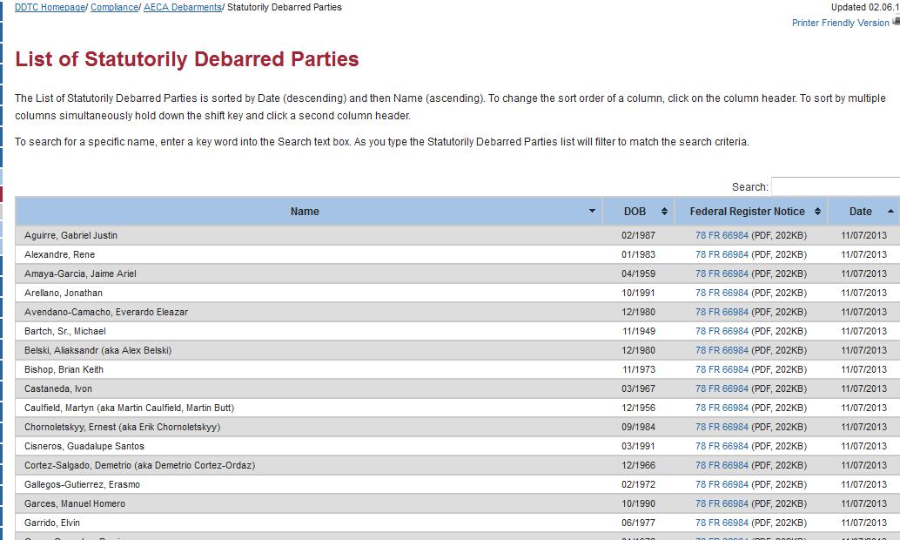

- Entity List- Regulated by the Federal Law 15CFR744
http://www.ecfr.gov/cgi-bin/text-idx?SID=bc69fef4d6679c27a617413ab8f3a74e&node=15:2.1.3.4.28&rgn=div5
To use the Entity List please click on the link above, by clicking the link it should take you to the following page below.

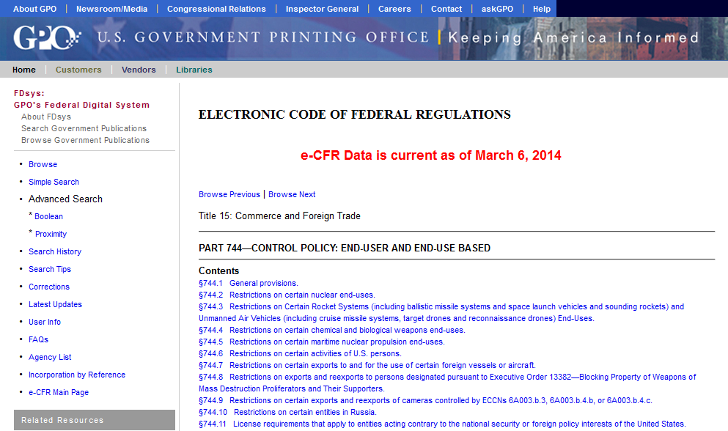

On this page you will find the complete federal regulation in its totality. However the list that you are looking for will be near the bottom of the page. The table that you need looks like the following:
