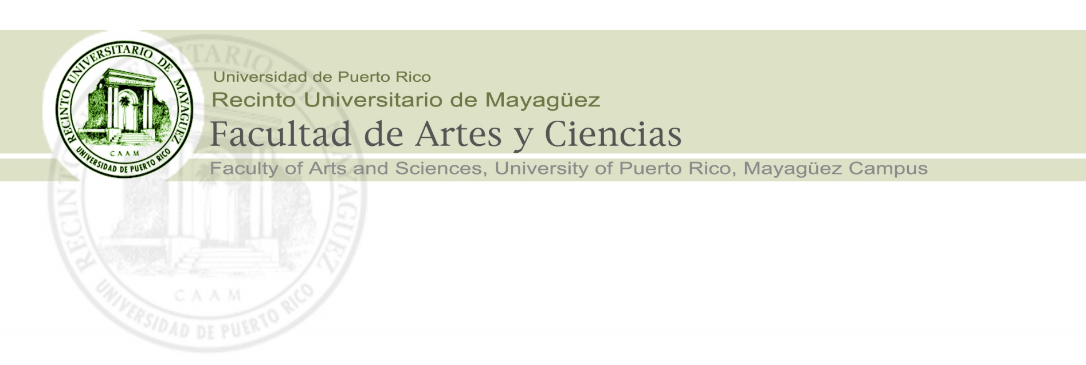
Dean’s Office
Oficina del Decano

Guidelines/Checklist for Creating a Tenure/Promotion File
Arts and Sciences (A&S) Faculty Personnel Committee (PC)
October 13, 2019

A) _____
- (All papers in the final file should be on one side only, regular letter size (8.5 x 11) paper?)
- The papers should be printed (or scanned) in portrait orientation.
- The A&S, Faculty PC provide the appropriate Appendices [B, F, G, I, L, COE] at:
www.uprm.edu/arci/comite-de-personal
B) _____ A complete file—ready to leave the Department PC and Director, and go to the A&S Faculty PC—needs to have the following elements in this order covering the entire evaluation period, from the most recent to the oldest evaluations.
(Sharing this list should help the candidates to provide the materials they have in the appropriate format and order to their Departmental PCs as well)
In the case of files for tenure, the documents must have a “Recomendación de Permanencia Docente” page which precedes item 1 below and does not need to be numbered.

1) ___ official page stating candidate has seen this file and identifying how many pages it has, signed by candidate and director (or PC chair if director recuses self). This form also states that an electronic or digital copy of the file will be reviewed by the A&S Faculty PC members.

A recent (April 2019) Junta Administrativa certification (18-19-287) requires that all files be made available in digital format.

Although this official page is for the entire file, similar pages for each of the periodic evaluations should be included here. The page (or letter) for the periodic evaluations should state the Appendix C score for the period.

Any comments or questions by the candidate regarding the periodic evaluations or the tenure/promotion file should be included here.

Any response or reconsideration by either the department director or the department PC to a candidate’s comments should also be included.

NOTE: A candidate for tenure should have five (5) separate sheets corresponding to his/her yearly evaluations, showing that the candidate saw and discussed the evaluations. These pages will be from most recent to oldest.

2) ___ candidate’s self-evaluation narrative here describing their achievements and contributions to the department, faculty, campus, community, etc. (OPTIONAL, but highly recommended) This document, if included, it is recommended should not exceed three (3) pages.

If the candidate has submitted similar narratives for previous periodical evaluations, use only the most recent or cumulative version.

3) ___ Department Director's letter to the Dean recommending action (or not) which references the candidate’s files and the Department PC letter. If director recuses self, include recusal letter.
4) ___ Department PC letter directed to director, recommending action (or not). If director recuses self, then this letter is directed to the Dean of Arts & Sciences.
5) ___ Appendix B—Resume— (the candidates provide this for each evaluation period; use most recent version). Note that this is different from and cannot be replaced with the candidate’s CV.
6) ____Appendix C —created by Department PC— with the candidate’s scores on the F, G, COE, I, and L forms and the self-evaluations scores on these forms where applicable.
The Appendix C consists of two pages. The first page of this appendix section has the most recent evaluation and the second page is the cumulative or longitudinal and summarizes the information from the top pages of previous Appendix C.

The first page of this section will be the cumulative or longitudinal Appendix C and will identify the total time period included in the evaluation. The year in which a candidate applies for personnel action must appear in the Appendix C, even when the period evaluated is only for one semester in that year. Each periodical evaluation should appear in the appendix. Subsequent pages, in reverse chronological order, correspond to the periodical evaluations [yearly, for tenure] and consist of the Appendix C for each evaluation period.

NOTE: in following items 7-12, the candidate’s self-evaluations using the appropriate forms, are OPTIONAL and when provided will be used in calculating their scores for those forms on Appendix C. When the candidates do not provide self-evaluations, the departmental PC or student score provides the full weight for those calculations.
(See comment about self-evaluations with the COE form at #10 and #13.)

7) ___ next are all the Appendices F, in reverse chronological order, with PC appendices first and then the candidate's self-evaluations.

8) ___ next are the Appendices G forms as above.

9) ___ next are the “auto-COE” –these are self-evaluations done by the candidates using the appendix that students used.

Appendix H—the former student evaluation appendix— is no longer used by students and will not be accepted for self-evaluation purposes.

While optional, JA Cert 17-18-183 makes filling out auto COEs highly useful and highly recommended.
10,11) ___ ; ___ next are Appendices I & L (when applicable) as with F & G.
12) ___ next are copies of all the student evaluations (COE), most recent to oldest. Here the professor provides to the PC a table summary showing COE average scores for each semester under the evaluation period as well as the total number of students responding per semester, the total number of students registered that semester and the pondered or weighted average. This table should be the first page of this section. This table support corresponding averages in Appendix C.

The professor or the Department Director must provide the graphic showing how COE scores vary from semester to semester or year to year. This graphic, when included, should be place just after the summary table.

The Junta Administrativa has a certification [JA Cert 17-18-183] for when student COE scores are not to be used and in these cases, the full weight for this part of the evaluation would be based on the self-evaluation. For this reason, the A&S PC recommends that all professors be made aware of this and that they provide self-evaluations using the COE forms.

Department chairs, PC chairs, professors and students need to be informed about this certification and its implications.

Candidates do not need to turn in the students’ answers to the open-ended [#43, 44, and 45] or subjective questions in the COE. They should NOT be included in materials provided to the A&S PC with these files. Their purpose is for the professor (and perhaps Department Director, as his/her supervisor) see where the professor is doing well and where he/she needs to improve. They do NOT belong here and will be removed if included.

13) ___ next are copies of the “carga académica” or academic program for the last 5 years –or the required period. These support the weights for components evaluated in the Appendix C, and help determine how to fill out Appendix C--how much [%] of a candidate's “carga” or load is Teaching, how much is Research, how much Administration, and so on.
14) ___ next is evidence of Attendance at Faculty meetings and then Department meetings. A summary sheet which covers both types of meetings and establishes scales to assign points in case of missed meetings should precede any pages documenting semesters or years of meetings covered in the evaluation period.

Recommend a summary sheet to put on top of all these pages, and even better to use the summary and let the department keep the originals. Also, a scale or table of equivalencies
for perhaps missing (excused absences?) some meetings may be helpful and avoid discussion of whether missing a meeting or two one year means the professor must receive a 4 instead of a 5. If all departments use the same sheet, that might be helpful.
15) ___ All class observation reports carried out during the evaluation period.
NOTE: It appears that JA Certification 86-87-476 does not require class evaluations.

The A&S PC notes that that classroom observation visits are optional, but highly recommended. Each department will have its own criteria. The mandatory or optional nature of class visits should be determined by the departments and their historical use [“uso y costumbre”], and documented. A copy of this decision should be provided to the A&S PC. It is not an ad-hoc decision made by the departmental PC in a given year for convenience, nor is it optional on the part of the individual professor. A professor should, however, always be able to request a visit from his/her PC.

Clearly, PC visits have the potential to help candidates improve and documenting departmental guidance and interaction (see item 1 above) with professors in an ongoing way can help avoid unpleasant surprises later in the PC tenure/promotion process.

16) ___ finally, attach COPIES of forms/certificates or other documents supporting the departmental letter, curriculum vitae, publications, presentations, etc. This should not be too extensive – use your judgement.

Additional Comments

For # 2, candidate’s self-evaluation narrative:
The three (3) pages of the candidate’s self-evaluation narrative describe their achievements and contributions to the department, faculty, campus, community, etc. with special attention to elements that might not be adequately represented or reflected in the usual appendices and forms. This helps the PC write a better letter to the Director, the Director to draft a better letter to the Dean, and the Dean to better defend cases to the Junta Administrativa.

As an example: Research done without release time or external/institutional funding cannot be described using Appendix I, and therefore might be undervalued or overlooked.

For #15, classroom observation visits:

The JA Cert 86-87-476 does not require classroom visits.
However, these visits allow PC members to better support the scores they assign on appendices F and G, and to support the positions they take in their letter to the Department Director. These observations may also give Department Directors and Deans additional evidence to support their positions. Ultimately, they may support recommendations for improving a candidate’s performance which the major goal of supervision.

When suggestions are made in a timely way, they help the candidate improve their performance during the tenure / promotion cycle and also document that guidance was provided before major personnel decisions were made.

