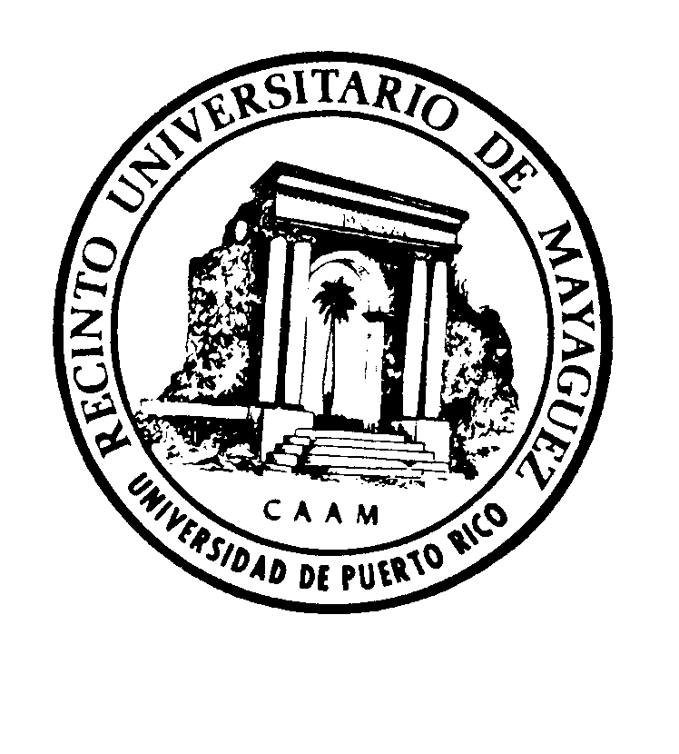
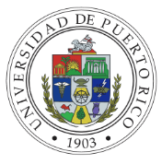
University of Puerto Rico
Mayagüez Campus
College of
Department of
Program

Course Syllabus

- General Information:
Alpha-numeric codification:
Course Title:
Number of credits:
Contact Period: ej. 2 hours of lecture and two hour laboratory per week

- Course Description:
English: General ideas, materials, main themes, purpose, approach, methodology, goals and components (no more than 1000 characters). The descriptions of permanent courses are available at http://www.uprm.edu/catalog/, and at Mi Portal (Sistema de Cursos).
Spanish: No more than 1000 characters. Descriptions available at Mi Portal (Sistema de Cursos)
- Pre/Co-requisites and other requirements:
- Course Objectives:
Be sure to include measurable objectives, centered on the students, and what they should be able to accomplish after completing the course.
5. Text Book:
Include textbook reference.
6. Course time frame and thematic outline
Outline | Contact Hours
Total hours: (equivalent to contact period)

7. Instructional Strategies:
conference discussion computation laboratory cooperative learning simulation

problem-based learning seminar with formal presentation seminar without formal

presentation workshop online instructional modules discussion forums

art workshop practice trip thesis special problems tutoring

research independent study case studies asynchronous videoconference

cyber chatschats other, please specify:
8. Minimum or Required Resources Available:
Materials, equipment, and physical facilities needed to fulfill the course objectives. Include all resources required for online or hybrid courses.
9. Evaluation Strategies
 | Quantity | Percent
Exams
Final Exam
Short Quizzes
Oral Reports
Monographies
Portfolio
Projects
Journals
Other, specify:
TOTAL: |  | 100%

10. Reasonable Accommodation (Law 51)
The University of Puerto Rico at Mayagüez (RUM) recognizes that each student has an inherited right to request reasonable accommodation according to Law 51: Law for Integral Educational Services for People with Disabilities. Every student has the right to receive reasonable accommodation if he/she presents the necessary evidence to be evaluated by the Office of Services to Students with Disabilities (OSEI-RUM), and the related information can be found at the following link: https://www.uprm.edu/cms/index.php/page/85. If your case is approved by OSEI-RUM, you will receive reasonable accommodation in your courses and evaluation, and you must contact each professor for course registered. For additional information contact OSEI-RUM at Sánchez Hidalgo 410 or via telephone 787-832-4040 extension 3107.
11. Academic Integrity:
The University of Puerto Rico promotes the highest standards of academic and scientific integrity. Article 6.2 of the UPR Students General Bylaws (Board of Trustees Certification 13, 2009-2010) states that academic dishonesty includes, but is not limited to: fraudulent actions; obtaining grades or academic degrees by false or fraudulent simulations; copying the whole or part of the academic work of another person; plagiarizing totally or partially the work of another person; copying all or part of another person answers to the questions of an oral or written exam by taking or getting someone else to take the exam on his/her behalf; as well as enabling and facilitating another person to perform the aforementioned behavior. Any of these behaviors will be subject to disciplinary action in accordance with the disciplinary procedure laid down in the UPR Students General Bylaws.─.
12. Policy Against Discrimination Based on Sex, Sexual Orientation, and Gender Identity:
The University of Puerto Rico prohibits discrimination based on sex, sexual orientation, and gender identity in any of its forms, including that of sexual harassment. According to the Institutional Policy Against Sexual Harassment at the University of Puerto Rico, Certification Num. 130, 2014-2015 from the Board of Governors, any student subjected to acts constituting sexual harassment, may turn to the Office of the Student Ombudsperson, the Office of the Dean of Students, and/or the Coordinator of the Office of Compliance with Title IX for an orientation and/or formal complaint.

13. Sexual Harassment: Certification 130-2014-2015 states:
Sexual harassment in the workplace and in the study environment is an illegal and discriminatory act and is against the best interests of the University of Puerto Rico. All persons who understand they have been subject to acts of sexual harassment at the University of Puerto Rico may file a complaint and request that the institution investigate, where necessary, and assume the corresponding action by the university authorities. If the complainant is a student, he or she must refer his or her complaint to the Office of the Student Ombudsperson or that of the Dean of Students.

14. Certification 06-43 of the Academic Senate states, "The academic guidelines for offering online courses," defines:
Traditional face-to-face courses are those that have less than 25% of the course's regular contact hours via the Internet. Therefore, a three-credit course will be considered "face to face" if, of the 45 hours of regular contact, 11 or less are taught via the Internet. According to certification 16-43 of the Academic Senate, a course may include up to 25% of its total contact hours via the Internet. The objective of this is so that all professors have this alternative in the case of any unscheduled eventuality.

15. Grading System
Quantifiable (letters) Not Quantifiable

16. Bibliography:
Author, A., and Author, B. (20XX) The Book's Title. City, State: Publisher. Include the textbook as the first bibliography. Nothing older than 5 years. (Justify otherwise)

