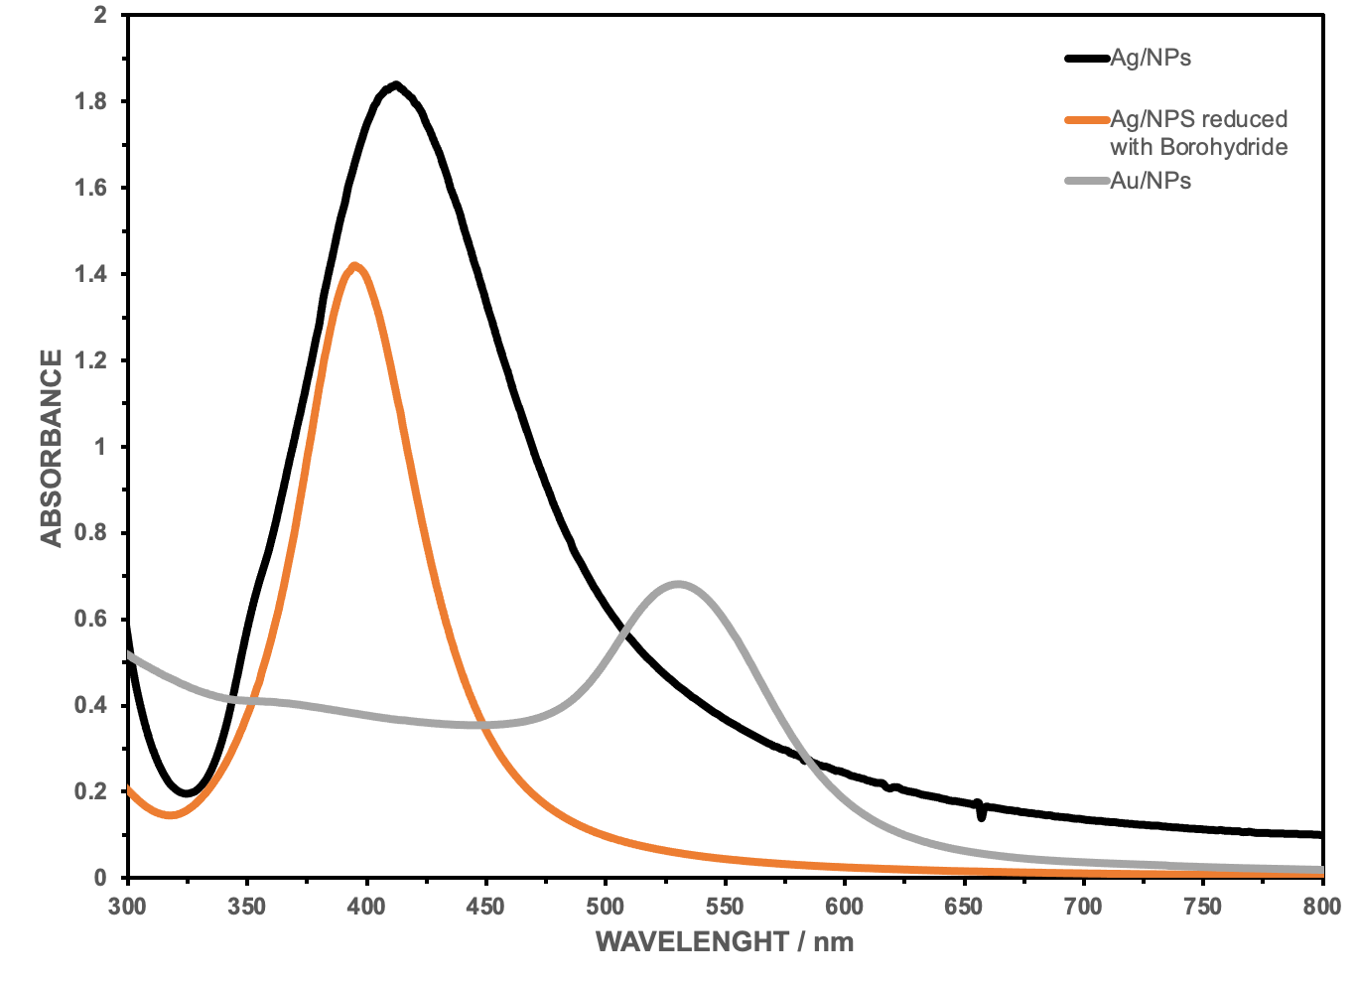

**395 nm**

**410 nm**

**530 nm**

Figure 1. UV – Vis spectra of prepared Ag/Au NP.

Figure 1. UV-Vis spectra obtained for (a) AgNP, AgNP reduced with NaBH4 (borohydride), and (b) AuNP.