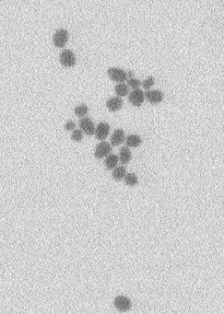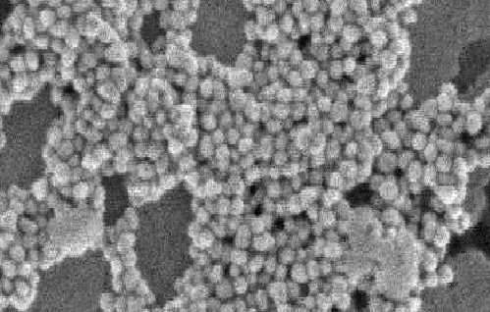
(a)
(b)

Figure 2. Scanning electron microscope (SEM) micrographs were obtained for (a) Ag and (b) Au nanoparticles.

