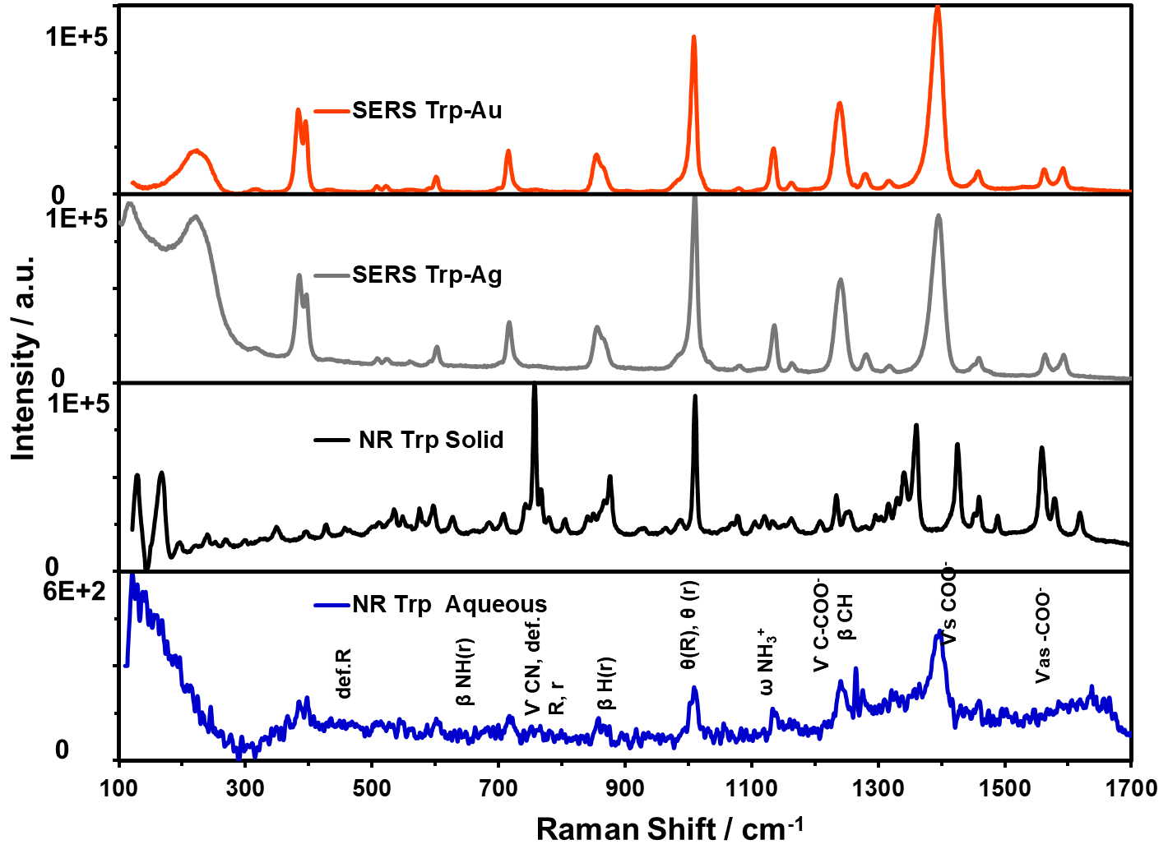

Figure 4. Comparison of Raman spectra of L-Trp: (a) NR spectrum aqueous; (b) NR spectrum of solid; (c) SERS spectrum on Ag NP; and (d) SERS spectrum on Au NP.