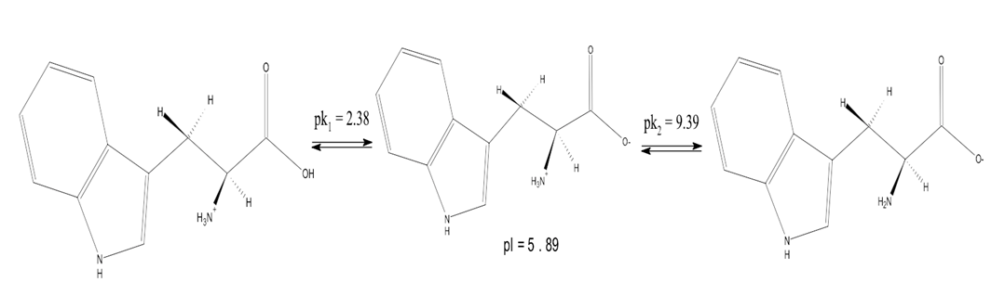

Figure 5. Three ionic molecular forms of L-Trp.