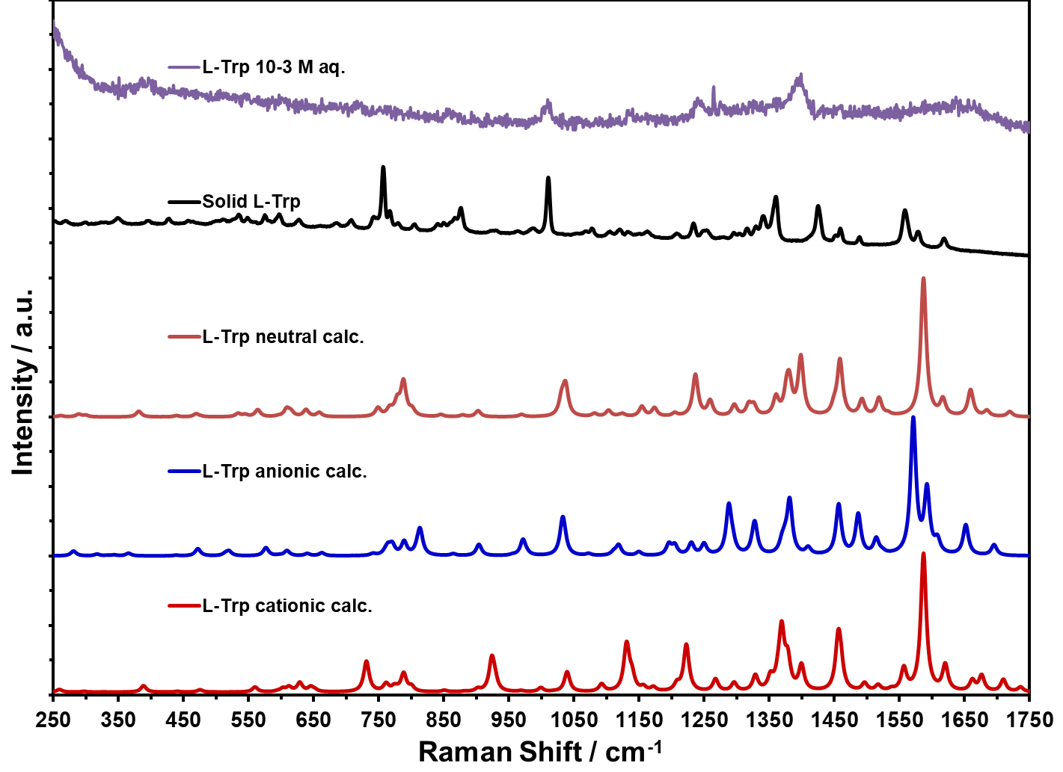
(e)
(d)
(c)
(b)
(a)
Figure 6. Comparison of Raman spectra of L-Trp experimental: (a) NR spectrum of L-Trp aqueous solution; (b) NR spectrum of solid; (c) calculated Raman spectrum zwitterion; (d) calculated Raman spectrum of anionic form; (e) calculated Raman spectrum of cationic form

