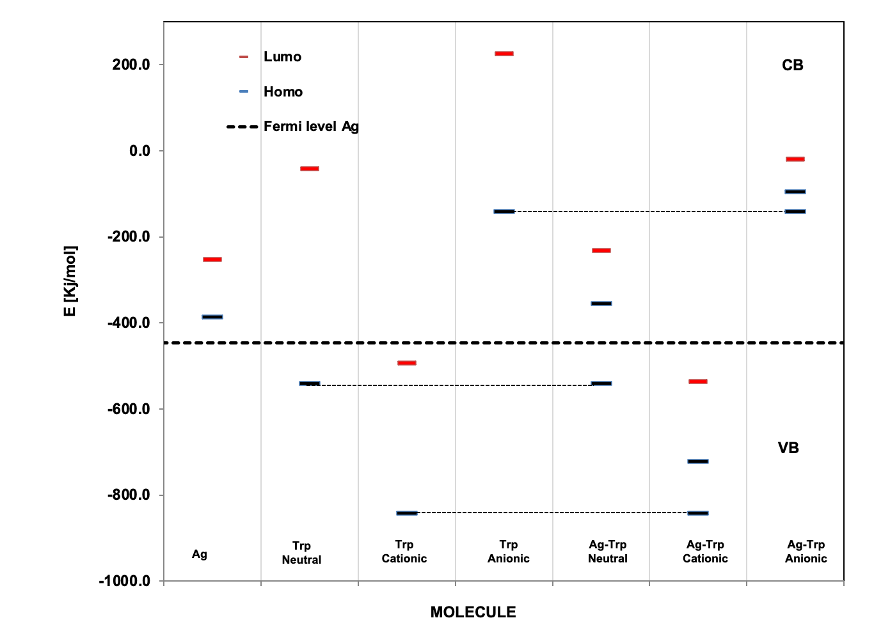
(a)
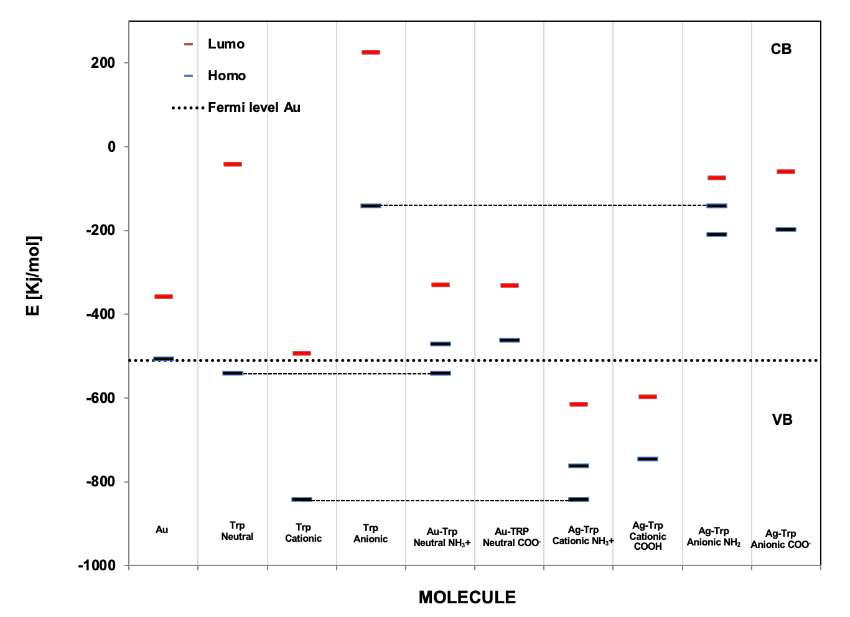
(b)
Figure 7. Diagram of the HOMO-LUMO energy gap of L-Trp in its three forms calculated at the B3LYP/6-311G level on (a) 10 atoms Ag (1,0,0) surface; (b) 10 atoms Au(1,0,0) surface.

