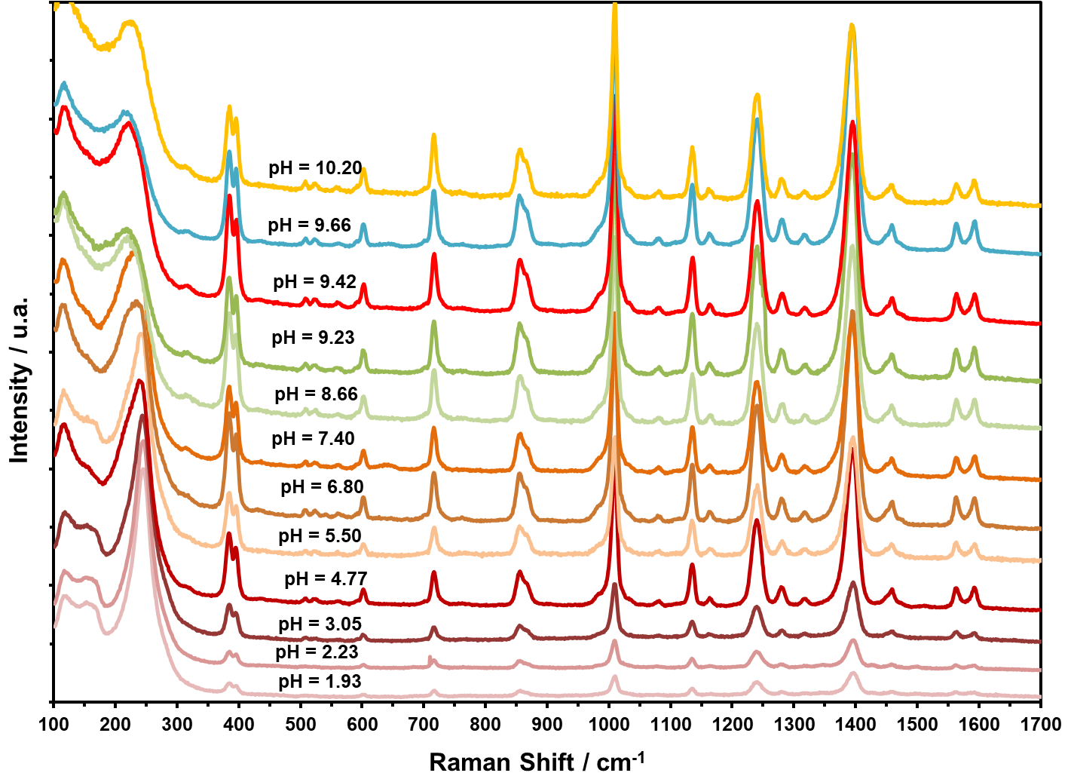
- L-Trp/Ag
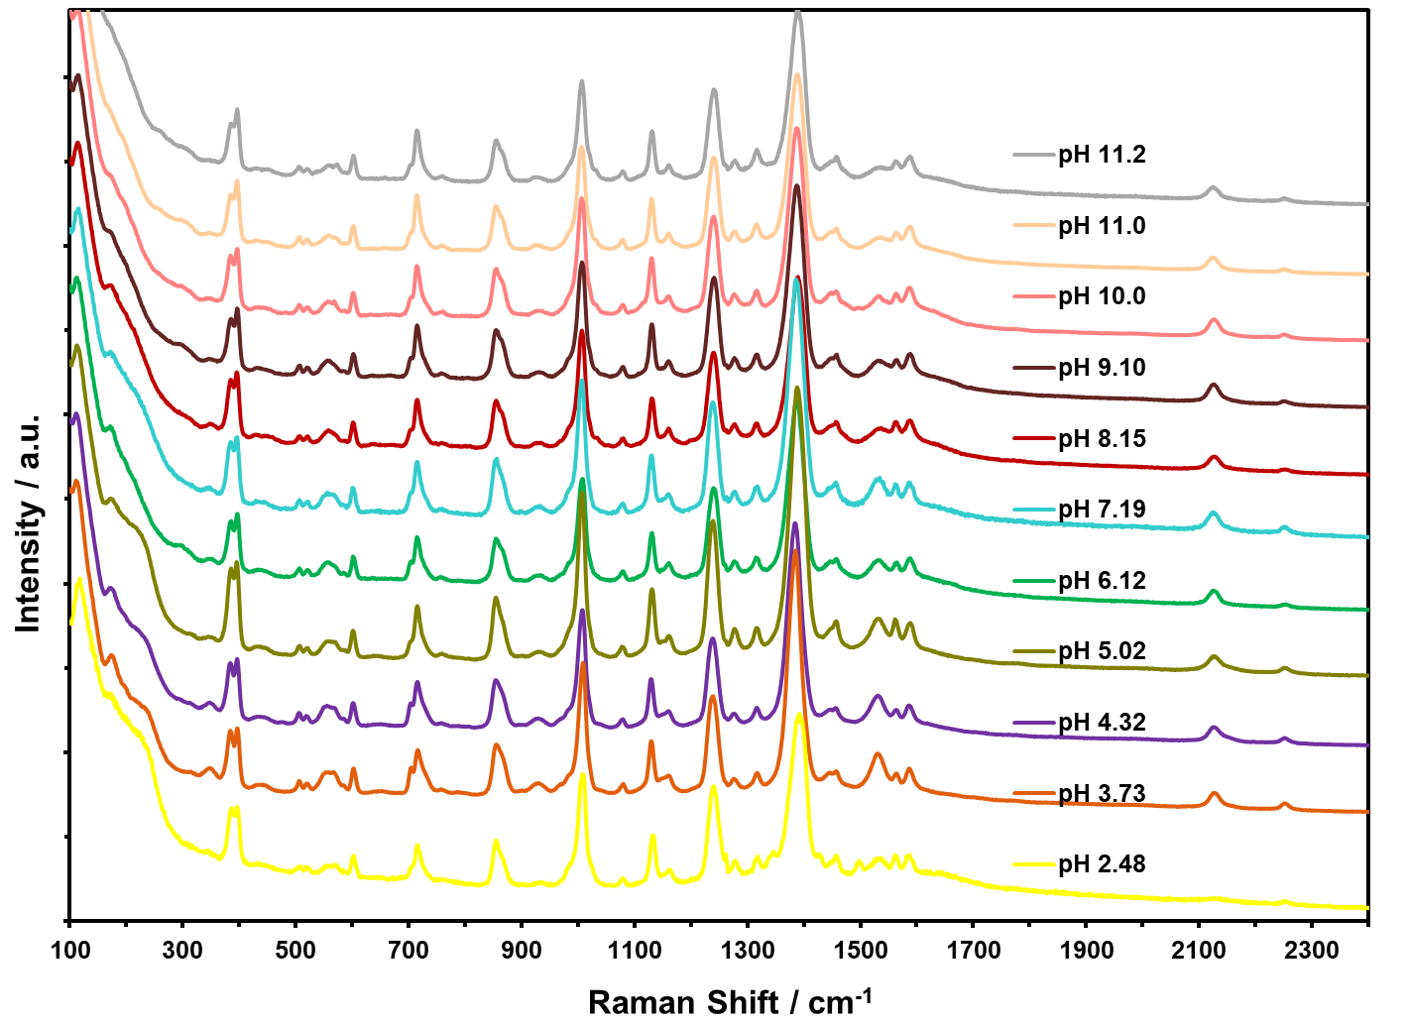
- L-Trp/Au

Figure 8. SERS spectra of L-Trp at different pH values at 785 nm with (a) AgNP and (b) AuNP.

