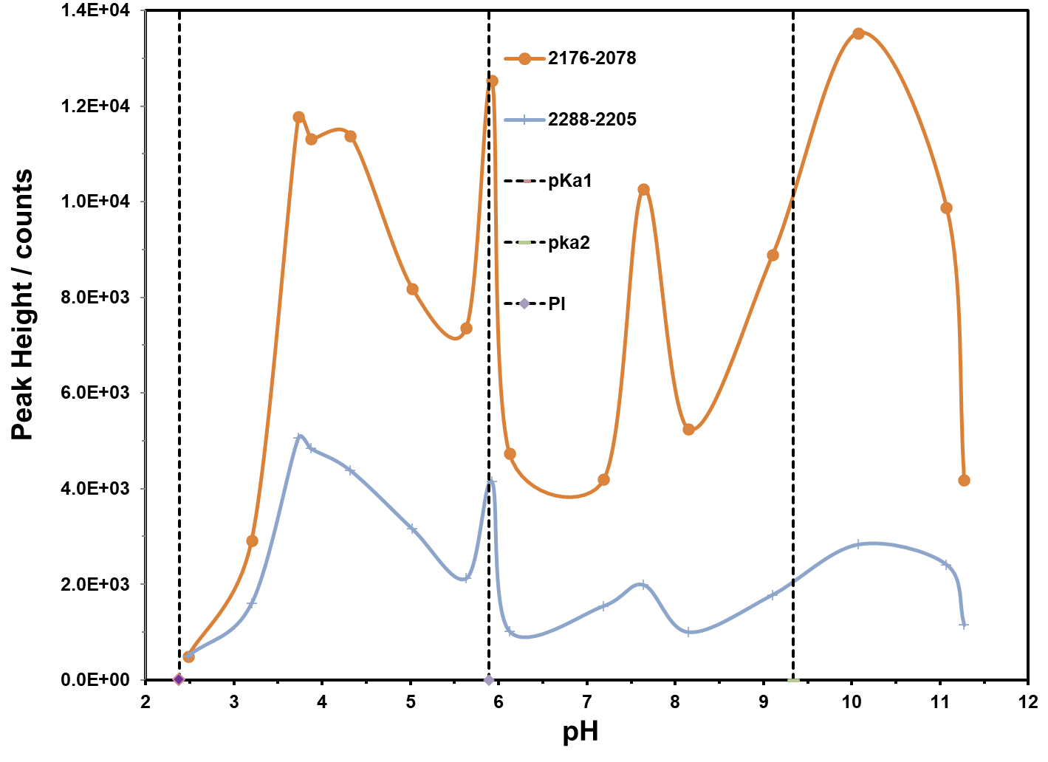
- L-Trp/Ag
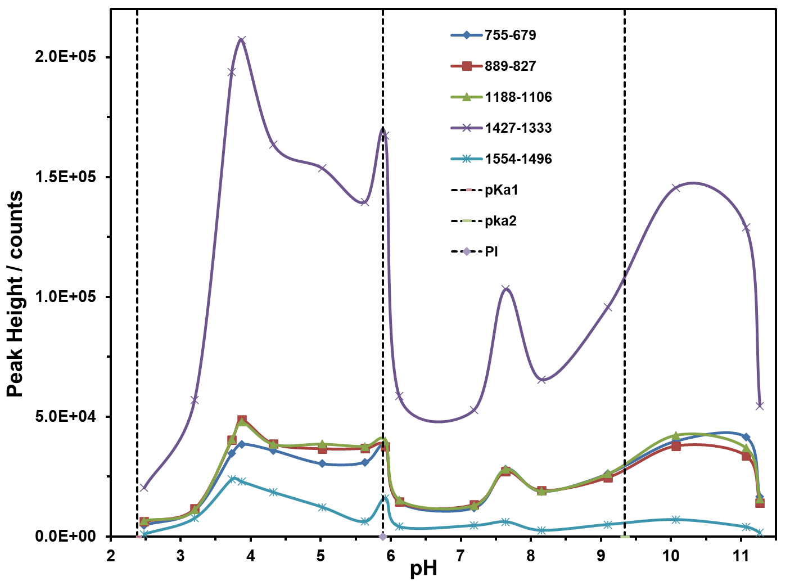
- L-Trp/Au

Figure 9. (a) Dependence of SERS signal of L-Trp with AgNP and (b) AuNP.

