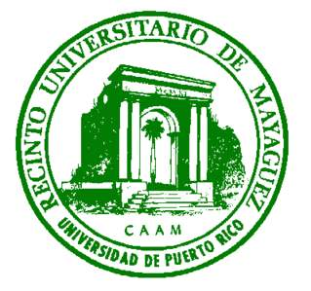
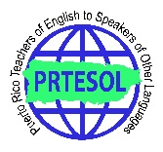
43rd ANNUAL PRTESOL CONVENTION
Reading the Word, Reading the World:
Working towards Social Justice and Peace in the English Classroom
University of Puerto Rico at Mayagüez
Friday and Saturday, November 18-19, 2016
CALL FOR PRESENTATION PROPOSAL
Extended Due date: September 15, 2016

Puerto Rico’s financial, political, social, and educational situation has been in a steady decline during the past decades. However in the last couple of years, our presence in the news is mostly tied to that which highlights mostly what is wrong. This struggle is also evident in our schools, particularly when it comes to our English educators who are leaving the Island in search of better opportunities for them, their families, and their careers. There is a sense of urgency to provide teachers with a new take on education through critical pedagogy and steer them away from the fluffy stuff which keep teachers busy and our students alienated from our realities.

OBJECTIVES OF THE CONVENTION:
- Open a space for the discussion of Critical Pedagogy in the English classroom.
- Inform on techniques and strategies that promote a participatory approach.
- Create more awareness related to critical pedagogy and its tenets.

POSSIBLE PRESENTATION TOPICS:

- Becoming a critical educator ● Social and emotional literacy
- Character education ● Creating spaces for interdisciplinary alliances
- Social justice for a diverse population ● Classroom strategies which support
- Research-based programs on critical pedagogy ● Best practices that promote critical pedagogy
and promote a peaceful environment ● Reconstructivism
- Interdisciplinary, integrated, thematic ● Trends and benefits of a participatory approach
unit design addressing social justice ● Competencies required in the 21st Century to
- Cooperative and Collaborative Grouping promote critical educators and learners
- Authentic Assessment or Performance Assessment ● Parental and Community Involvement to promote
- Multimedia/technology to enhance critical pedagogy social justice and peace
● Differentiated instruction ● Problem-based learning
- Using video production, arts, and music to teach social justice

PRESENTATION FORMATS:
Workshop (60 minutes) Workshops should engage the participants in practical activities that can be transferred to the classroom. | Demonstrations (60 minutes) Demonstrations should be activities shown in a step-by- step process.
Papers (60 minutes). Papers should be based on current research and theory. They should also provide practical benefit to the audience. | Panel (60 minutes) Group of 3 to 4 experts who will discuss a topic from different perspectives.
Poster Presentation (60 minutes). A visually explanatory exhibit that allows a short, informal discussion between the presenter(s) and attendees, as attendees circulate within the poster-session area. Poster sessions serve as an important and interactive forum for sharing professional ideas and for receiving feedback. Poster exhibits are set up side by side within the session area during the hour before the session and dismantled within the hour afterward. | Round Table Discussions (60 minutes) Peer-to-peer facilitated discussions with a small group of attendees. The facilitator should have a strong knowledge of the topic and be able to engage everyone in the discussion.
Submit proposals to Program Chair: Jennifer Alicea Castillo: prtesolproposal@gmail.com

Presenter Conference fee: -Member: both days: $80; one day: $40 – Student Presenter (Member): both days: $60; one day: $30
-Non-member: both days $100; one day: $50 –Student Presenter (Non-member): both days: $80; one day: $40

