**WEEK AT A GLANCE:**

**November 20 to November 24, 2023**

# ANNOUNCEMENTS:

If your courses are in **CH 123, 221, 224, 318, or 319, PLEASE contact Albert on how to use the new equipment. Thank you. Do not disconnect the computers to use your laptop. It will affect the configuration. Next room is CH 125—TBA.**

**Remember to turn off the computer if your class is the last one.**

**Please organize the chairs and clean the boards before leaving your classroom.**

**\*We are finding open classrooms without supervision during the days and evenings. Remember to close the door every time you finish your class.**

*Please, submit announcements of your activities or accomplishments to [ingles.uprm@upr.edu](mailto:ingles.uprm@upr.edu) by Thursday at noon. Thank you

\***Special Announcement:**

1. Dr. Maria del C. Quintero, Dr. Linda Rodriguez, and Dr. Hugo Ríos are the advisors of “The Bookworm Society*”*, a student association recently created and approved. They had their first meeting last Thursday (November 16, 2023).
2. Dr. Maria del C. Quintero’s paper titled “Reading the Shore from the ‘Edge, Unseen’: Kamau Brathwaite’s Tidalectics in William Carlos Williams ‘Flowers by the Sea’” was accepted for presentation at the William Carlos Williams Biennial Conference.
3. Professor Emily Hernandez Giovannetti and Professor Marién Villanueva Vega presented at *Caribe Plurilingüe XX* on Friday, November 17, 2023.

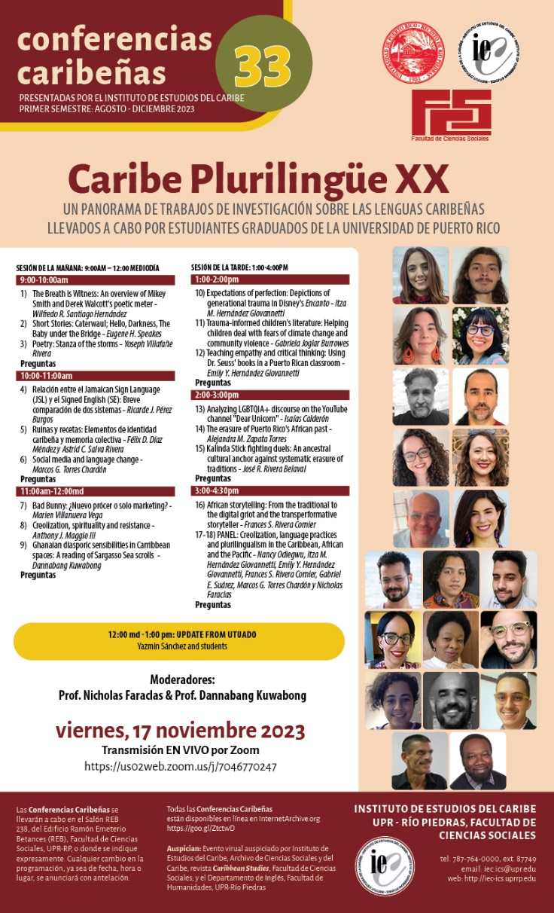

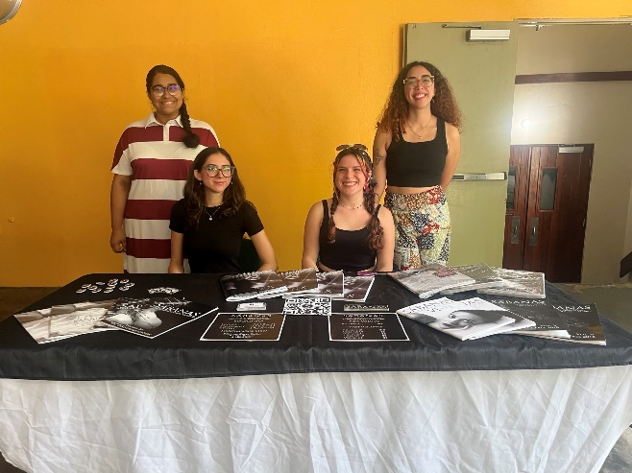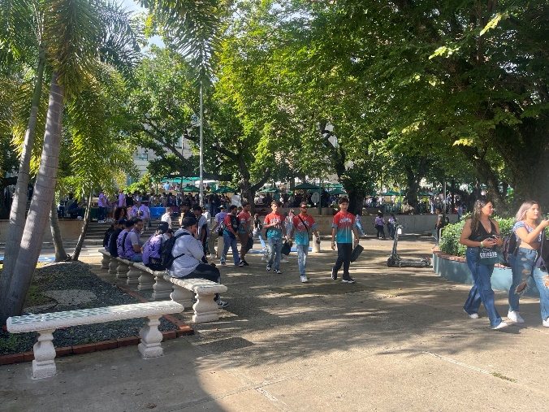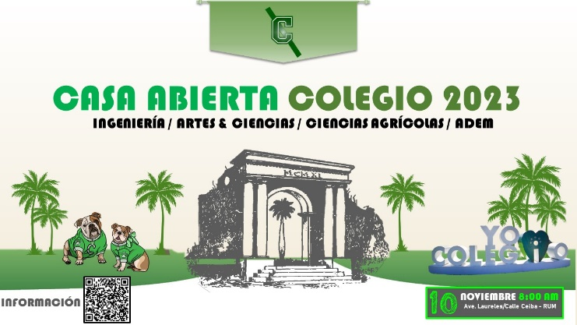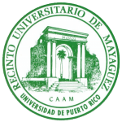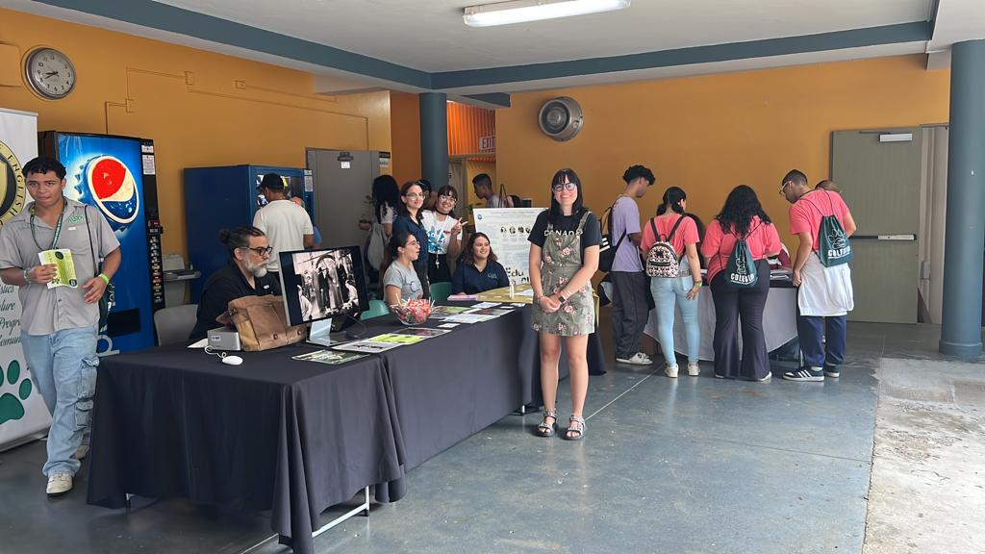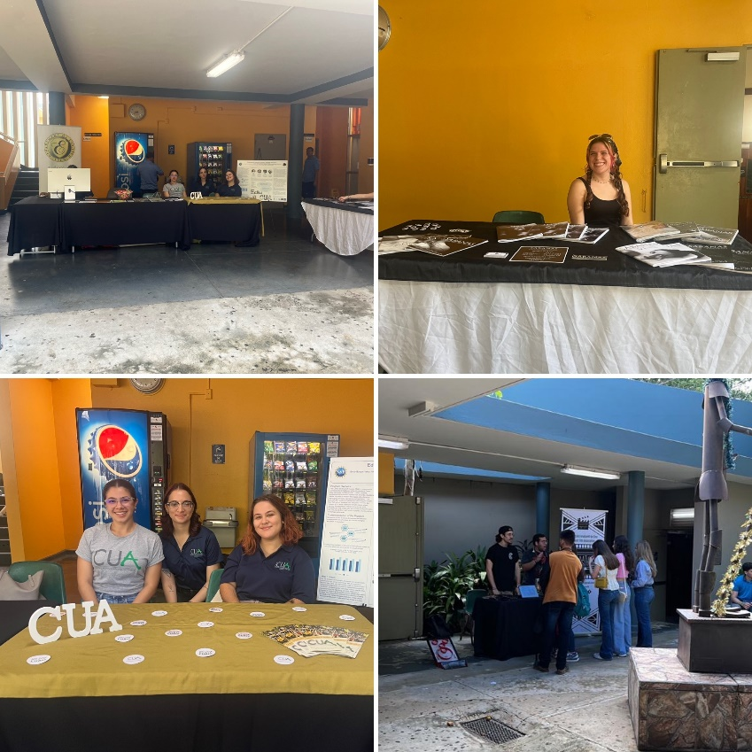

OPEN HOUSE

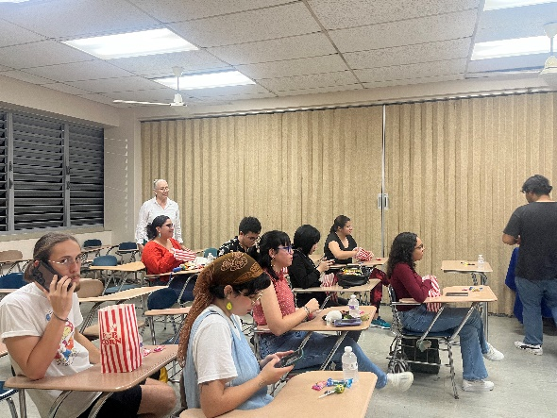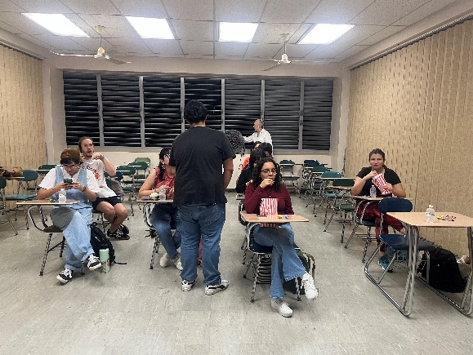

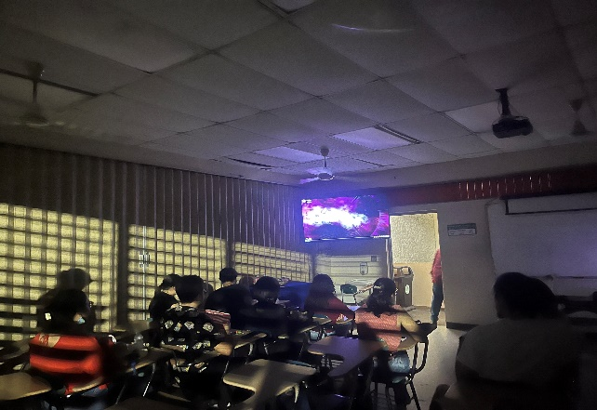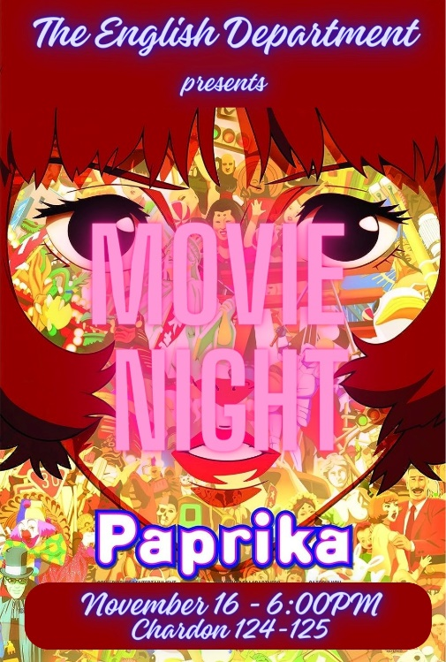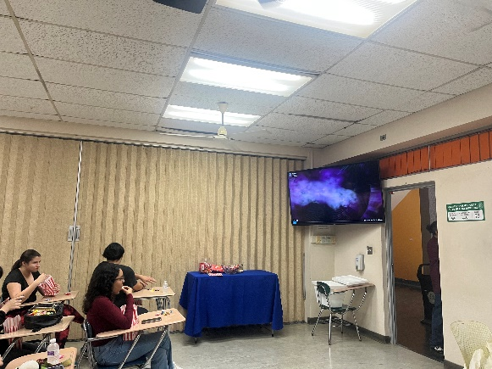

Our very first Movie Night!

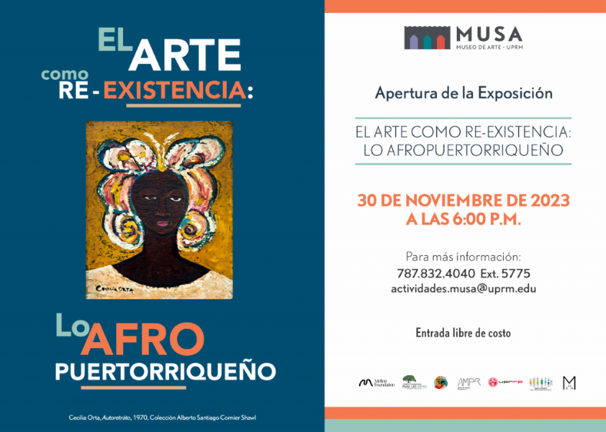

<https://www.uprm.edu/humanidades/2023/11/06/el-arte-como-re-existencia-lo-afropuertorriqueno/>

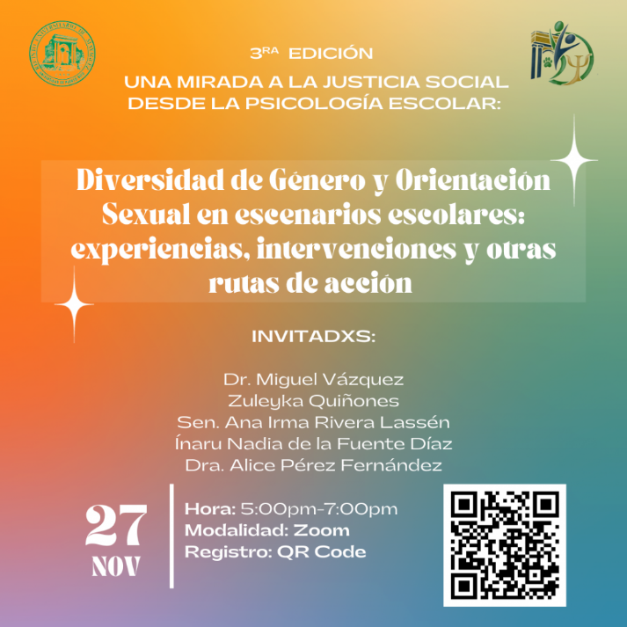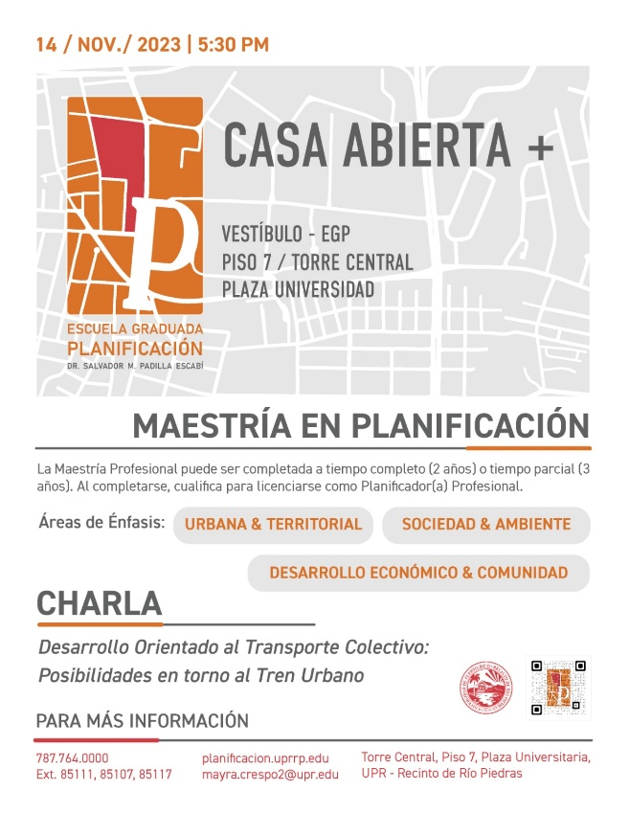

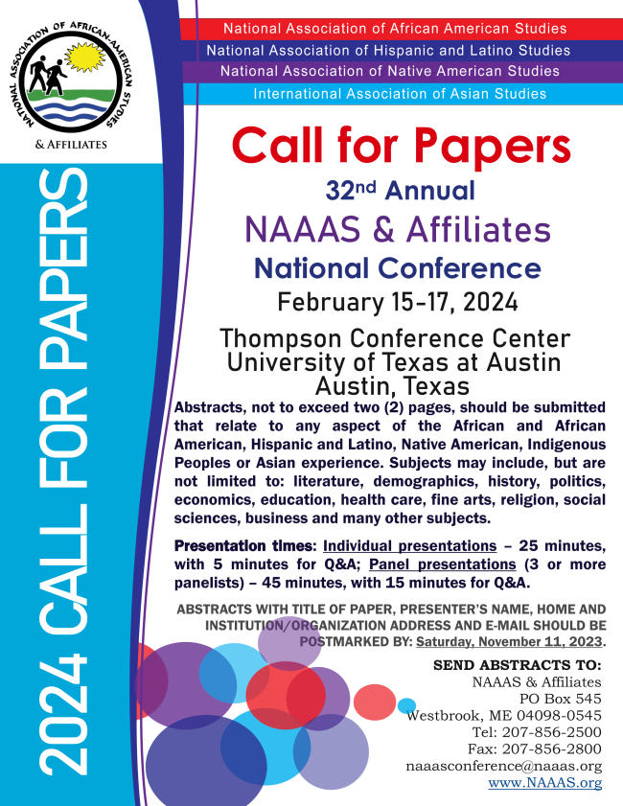

https://www.uprrp.edu/

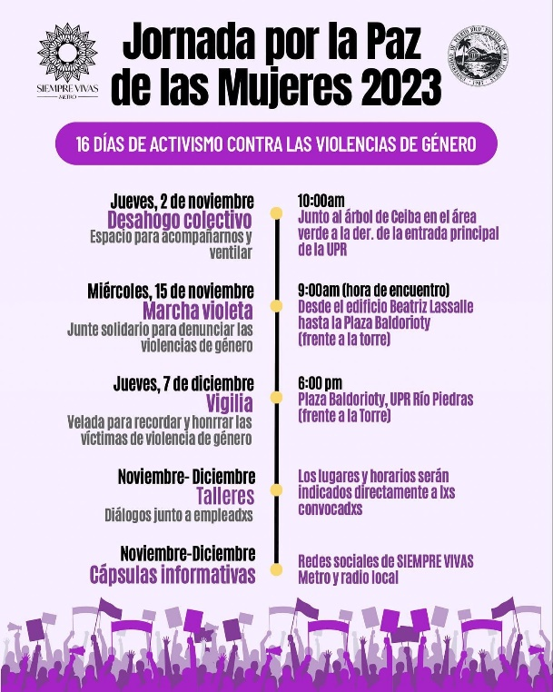

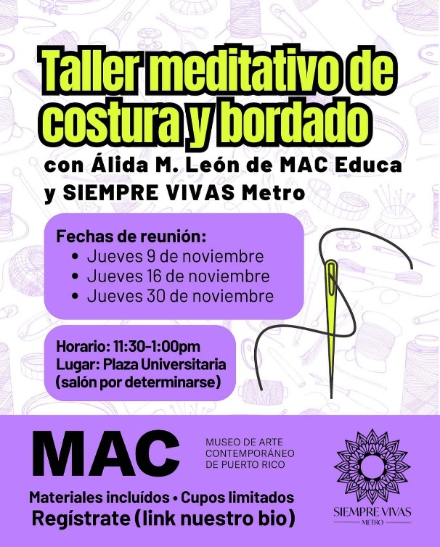

GHHHHh

Her Campus Fall 2023

H

* [Caribbean Cinemas | Radical](https://caribbeancinemas.com/movie/9031/)

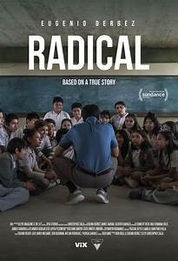

***GENRE:****Drama****RATING:****NR****RUNNING TIME:****2:02****RELEASE DATE:****November 2, 2023****STARRING:****Eugenio Derbez, Daniel Haddad, Jennifer Trejo, Mia Fernanda Solis****DIRECTOR:****Christopher Zalla****WRITER(S):****Christopher Zalla, Joshua Davis****MOVIE SYNOPSIS:****Based on a true story, it follows a teacher in a Mexican border town filled with neglect, corruption, and violence, as he tries a radically new method to unlock his students' curiosity, potential, and perhaps even genius.*

<https://docs.pr.gov/files/Estado/Documentos%20Administrativos/Proclamas/CP882023.pdf>

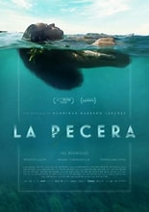

COMING SOON!

C

|  |  |
| --- | --- |
| **Activities** | |
| Monday,  November 20, 2023 | **FERIADO** – Día de la Cultura Puertorriqueña y Descubrimiento de Puerto Rico  (Calendario Académico) |
| Tuesday,  November 21, 2023 | **CHARLA – “**Inclusión de estudiantes con autismo en el ambiente universitario”.  De 10:30 AM a 12:00 PM, a través de *Teams*.  A cargo de Jackeline Marcial.  Para más información, acceda: <https://new-cep.uprm.edu> (CEP)  **MARATÓN DEL PAVO –** saliendo a las 4:45 PM, desde frente de la Biblioteca General.  Inscripciones en: Maraton del pavo  y el día del evento, de 2:00 a 4:00 PM.  (Actividades Atléticas)  Turnos disponibles a los estudiantes para la **matrícula** de**l segundo semestre 2023-2024** en Mi Portal**.** |
| Wednesday,  November 22, 2023 | "Entre Café, Música y Arte" is celebrated every Wednesday of the month from 6 pm to 10 pm. |
| Thursday,November 23, 2023 | **FERIADO –** Día de Acción de Gracias.  (Calendario Académico) |
| Friday,November 24, 2023 | **RECESO** - Académico y administrativo de Acción de Gracias. (Calendario Académico)  **FORO COLEGIAL** – La revista informativa radial del RUM.  A las 6:30 PM, a través de Radio Universidad en el 88.3 FM en Mayagüez, el 89.7 FM en San Juan y por internet en <http://www.wrtu.pr/> .  Conducido por la Dra. Mariam Ludim Rosa Vélez, directora de la Oficina de Prensa.  (Prensa RUM) |

**Certificación Número 22-23-108** (Tercera Enmienda) de la Junta Administrativa, relacionada con el Calendario Académico 2023-2024.: [22-23-108 Calendario 2023-2024 Tercera Enmienda.pdf (uprm.edu)](https://dmsrum.uprm.edu/bitstream/handle/123456789/7574/22-23-108%20Calendario%202023-2024%20Tercera%20Enmienda.pdf?sequence=1&isAllowed=y)

# REMINDERS:

**THE ENGLISH WRITING CENTER:** For more information contact: [civis@uprm.edu](mailto:civis@uprm.edu)   
"Para su conocimiento, en el enlace encontrarán las [Á](https://nam02.safelinks.protection.outlook.com/?url=https%3A%2F%2Fwww.uprm.edu%2Farci%2Fwp-content%2Fuploads%2Fsites%2F95%2F2022%2F08%2FAreas-de-Estudio-Colegio-de-Artes-y-Ciencias-1er-semestre-2022-2023.pdf&data=05%7C01%7Crosa.roman3%40upr.edu%7C98f247d7cc5c4b0120b308dba5a3989e%7C0dfa5dc0036f461599e494af822f2b84%7C0%7C0%7C638285894350678047%7CUnknown%7CTWFpbGZsb3d8eyJWIjoiMC4wLjAwMDAiLCJQIjoiV2luMzIiLCJBTiI6Ik1haWwiLCJXVCI6Mn0%3D%7C3000%7C%7C%7C&sdata=X9TYPs045VluxlQjLdFYiPfUa6u7CUUadgNNjBLNxCk%3D&reserved=0)[reas de Estudio](https://nam02.safelinks.protection.outlook.com/?url=https%3A%2F%2Fwww.uprm.edu%2Farci%2Fareas-de-estudio%2F&data=05%7C01%7Crosa.roman3%40upr.edu%7C98f247d7cc5c4b0120b308dba5a3989e%7C0dfa5dc0036f461599e494af822f2b84%7C0%7C0%7C638285894350678047%7CUnknown%7CTWFpbGZsb3d8eyJWIjoiMC4wLjAwMDAiLCJQIjoiV2luMzIiLCJBTiI6Ik1haWwiLCJXVCI6Mn0%3D%7C3000%7C%7C%7C&sdata=eEXYLMUihJ%2B9vz%2BNYEGypSNtMqiRWoOqX3BQ%2FikRC3Q%3D&reserved=0)del primer semestre 2023-2024."

Please announce to your students that there are **computers available for lending**. Contact the Student Deanship.

**ACADEMIC CALENDAR**

[22-23-108 Calendario 2023-2024 Tercera Enmienda.pdf (uprm.edu)](https://dmsrum.uprm.edu/bitstream/handle/123456789/7574/22-23-108%20Calendario%202023-2024%20Tercera%20Enmienda.pdf?sequence=1&isAllowed=y)

# **UPDATING ENGLISH DEPARTMENT WEBPAGE**

# Thank you to those who have sent photos and updated their profiles.

Please visit the page and encourage our **retired faculty** to submit their photo and short bios. <https://www.uprm.edu/english/retired-faculty/>.

# **TRAVELING DURING THE SEMESTER**

If you plan to travel, please let the Office personnel know so that we can help you with the paperwork. This applies to both faculty and graduate students. Please check your email for the Travel Regulations in English.

If your trip is an official one with institutional funds, please contact Maricarmen Brito.

If you are planning to travel during the *Periodo Lectivo*, you must fill out [this form](https://www.uprm.edu/arci/wp-content/uploads/sites/95/2019/06/SolicitudViajeARCI.pdf).

If there are paid expenses or not, you must fill out this form:

[Solicitud y Autorización de Orden de Viaje](https://research.rcm.upr.edu/wp-content/uploads/sites/10/2022/06/Solicitud-y-Autorizacion-de-Orden-de-Viaje-29-abril-22.pdf)

# **CLASSROOM UPDATES**

**CH 005 remains unusable due to the heat. Therefore, classes have been moved to other classrooms on campus.**

**CH221, 224, 318 & 319:** have been converted into virtual classrooms. Training information will follow. **CH 125 is in process to be changed into a virtual classroom**

**CH 325 & 326:** Remain closed until further notice (Windows replaced). The Chancellor visited the space with Dean Omar Molina after the windows were replaced.

**Graduate Office Space CH 008-013:** Floor plans completed; Quotes pending. (Capacity: 17 cubicles and one conference room.)

# **TROUBLESHOOTING:**

Televisions, Computers, or Projectors **(Albert’s Office: 787-265-3836)**

Please notify Albert Cruz in writing: [albert.cruz@upr.edu](mailto:albert.cruz@upr.edu) and cc: [rosa.roman3@upr.edu](mailto:rosa.roman3@upr.edu)

Physical facilities like doors, locks, fans, windows, offices, lighting, and rodent infestation must be notified in writing: [maricarmen.brito@upr.edu](mailto:maricarmen.brito@upr.edu), [ingles.uprm@upr.edu](mailto:ingles.uprm@upr.edu) and cc: [rosa.roman3@upr.edu](mailto:rosa.roman3@upr.edu)

# **CARTELERA SEMANAL**

Please check for next week’s activities, conferences & other areas of interest in the link below: <https://www.uprm.edu/prensa/cartelera-semanal/>

# **LINKS**

[CERTIFICATION NUMBER 20-21-110, Proposal to schedule ordinary, faculty and departmental meetings.:](https://dmsrum.uprm.edu/handle/123456789/2928)

Academic Calendar (amended) <https://www.uprm.edu/cms/index.php?a=file&fid=20337>

# [PROFESSORS’ MANUAL:](https://www.uprm.edu/asuntosacademicos/wp-content/uploads/sites/45/2021/11/Manual-del-Profesor-2021.pdf)

[CERTIFICATION NUMBER 16-17-307 AMENDED - *Programa Docente, Programación de Matrícula, Ayudantías Graduadas*:](https://dmsrum.uprm.edu/handle/123456789/6039)

[CERTIFICATION 16-17-307 JA (JUNTA ADMINISTRATIVA) - *Programa Docente, Programación de Matrícula, Ayudantías Graduadas*:](https://dmsrum.uprm.edu/handle/123456789/2517)