WEEK AT A GLANCE:
November 6 to November 10, 2023

ANNOUNCEMENTS:
If your courses are in CH 123, 221, 224, 318, or 319, PLEASE contact Albert on how to use the new equipment. Thank you. Do not disconnect the computers to use your laptop. It will affect the configuration. Next room is CH 125—TBA.
Remember to turn off the computer if your class is the last one.
Please organize the chairs and clean the boards before leaving your classroom.

*We are finding open classrooms without supervision during the days and evenings. Remember to close the door every time you finish your class.

*Please submit announcements of your activities or accomplishments to ingles.uprm@upr.edu by Thursday at noon. Thank you

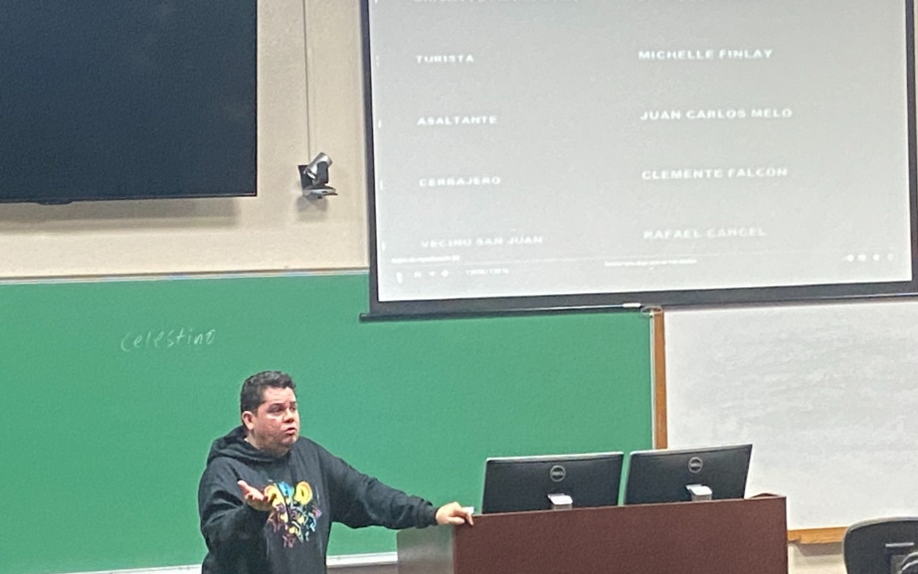
- Cinémathèque Activities:
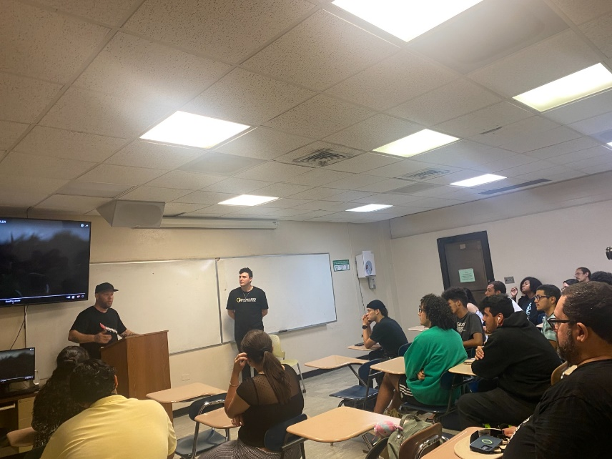
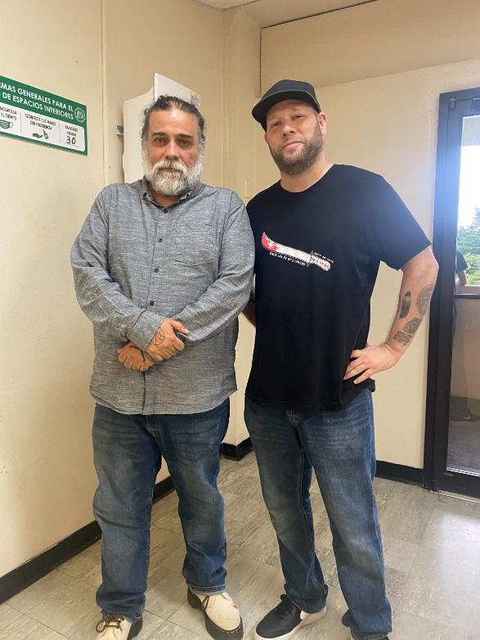
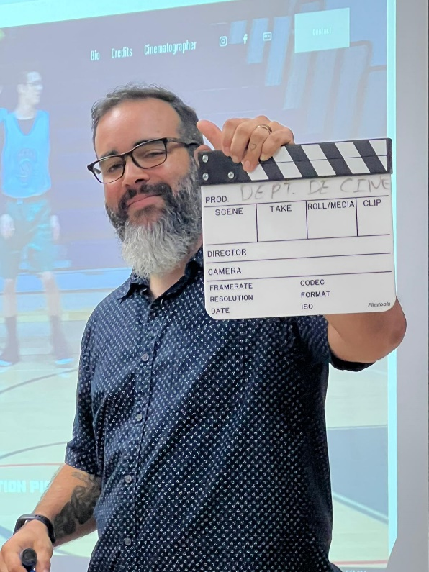
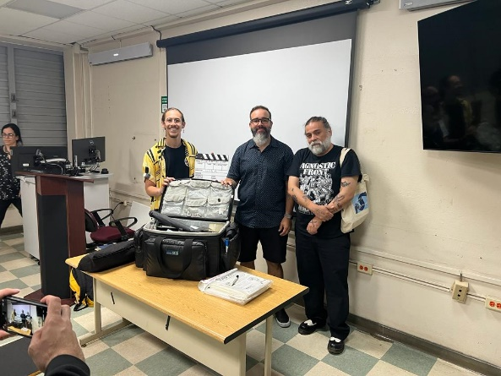

- Workshop – How to Manage Writing Anxiety
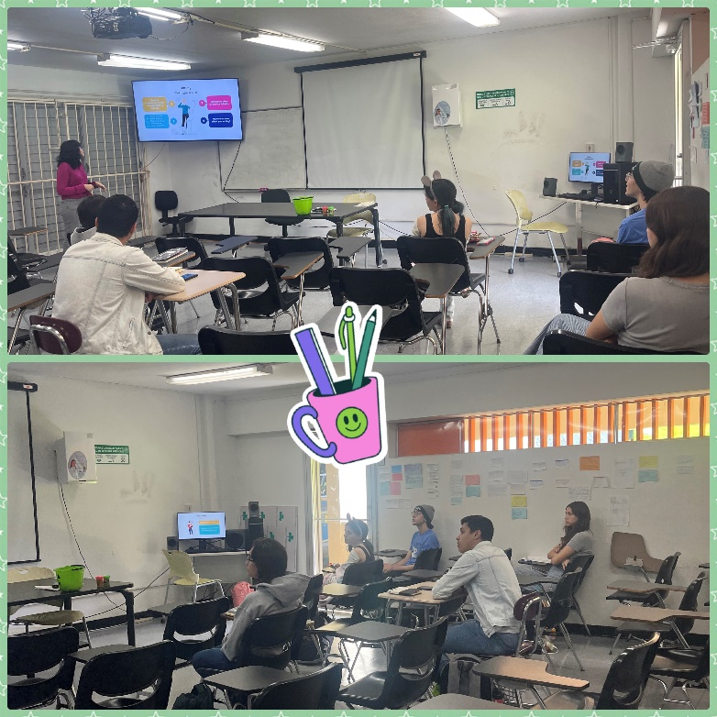
By: Prof. Emily Hernandez Giovannetti

- Carhianie J. Vargas Padín (undergraduate student)
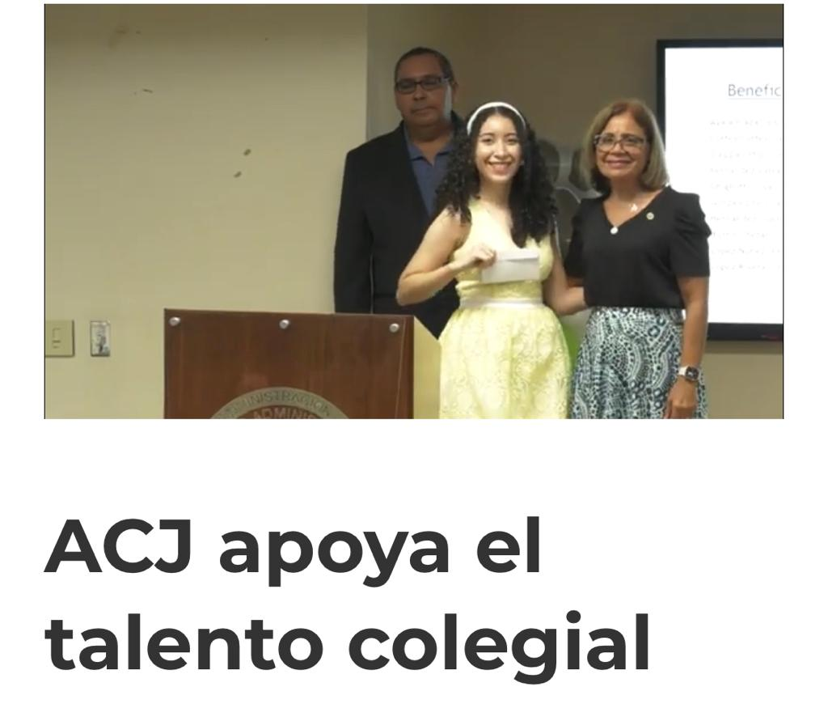
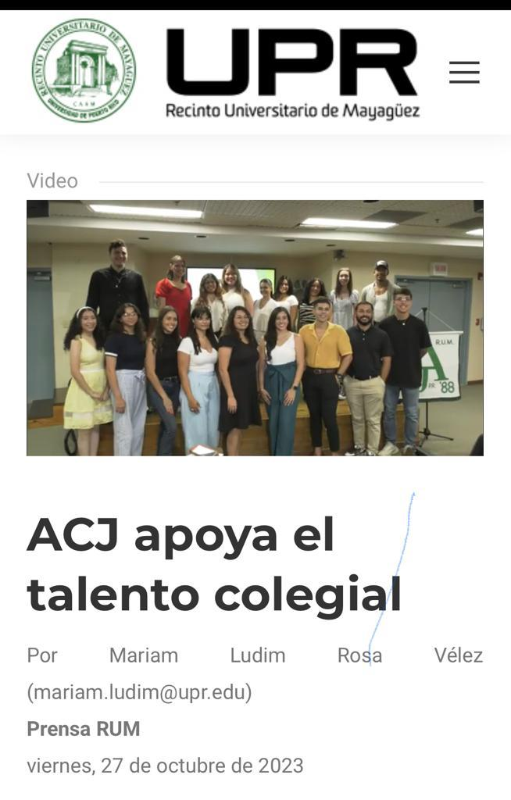

- Semester course preferences were received and used to create the schedule for next semester. Thank you for your prompt responses and feedback.
- First-year registration took place on October 30th and 31st.
- All Programas Docentes Fall 2023 were completed and submitted.
- MAEE Graduate Handbook and the MAEL Graduate Handbook will be handed in on Friday for GC Meeting to approve and ratify in the next Department Meeting.
- Dr. Jose M. Irizarry recently took part in a three-day live instructor workshop focused on Adobe products as part of the Film Studies NEH grant led by Dr. Hugo Rios. This workshop, organized by Certstaffix Training—a specialized firm in computer and business skills training—aimed to enhance skills pertinent to the department's future focus areas. These areas include publishing and producing video essays within Film Studies, fulfilling service and general education requirements for the general student population. Additionally, the skills acquired contribute to the ongoing INTD 3990 Internship in Sábanas Bilingual Literary Magazine, available since 2021. The ultimate goal is to benefit all students interested in these subjects within our academic community.
- Dr. Eric D. Lamore
  - published the invited chapter, “Reading the Edited ‘I’ in the Early Black Atlantic,” in A History of African American Autobiography, edited by Joycelyn K. Moody and published by Cambridge UP. This book celebrates the career of William L. Andrews (U of North Carolina at Chapel Hill), an influential scholar in African American studies.
  - published the invited chapter, “The Circulation of Early Black Atlantic Literature,” in African American Literature in Transition, 1750–1800 (vol. 1), edited by Rhondda Robinson Thomas and published by Cambridge UP.
  - published his fourth university press book, Abigail Field Mott’s Life and Adventures of Olaudah Equiano: A Scholarly Edition (https://wvupressonline.com/abigail-field-mott). This book is the latest addition to the Regenerations: African American Literature and Culture Series, edited by Joycelyn K. Moody and John Ernest, at West Virginia UP. The Bibliographical Society of America, Schomburg Center for Research in Black Culture, Haverford College, American Antiquarian Society, Library Company of Philadelphia, and Eccles Centre for American Studies at the British Library generously supported research for this book. To complete work on this project, Lamore also held Visiting Scholar appointments at the University of Chicago and New York University. Here are some assessments of the book:
    - “Eric D. Lamore’s multifaceted edition of Abigail Field Mott’s Life and Adventures of Olaudah Equiano challenges textual paradigms in early Black Atlantic studies by bridging divisions between literary history and book history. This much-needed volume documents an important chapter in the evolution of Equiano’s transatlantic posthumous reputation while introducing readers to a signal contribution to early African American children’s literature.”
William L. Andrews, University of North Carolina at Chapel Hill
    - “Think you’ve read the ‘authorized’ edition of Olaudah Equiano’s narrative? Eric D. Lamore’s edition of Abigail Field Mott’s Life and Adventures of Olaudah Equiano might have you question your choice. It is an incisive, must-read primer for anyone considering Equiano or early American book history, Black subjectivity, and authorship. Read this book—and learn to think in new ways about what it means to tell a Black person’s story.”
Tara Bynum, University of Iowa
  - completed a research fellowship at the Library Company of Philadelphia funded by the National Endowment for the Humanities (NEH). Lamore studied the transatlantic/transnational circulation of early Black Atlantic books during the summers of 2022 and 2023, delivered an invited presentation on archival methodologies for undergraduate and graduate students attending the African American Studies Institute at the Library Company, an initiative funded by the Andrew W. Mellon Foundation, and completed parts of his next book, a monograph, titled “Unstable as Water”: Early Black Atlantic Literature and Textual Fluidity. Benjamin Franklin founded the Library Company in 1731.

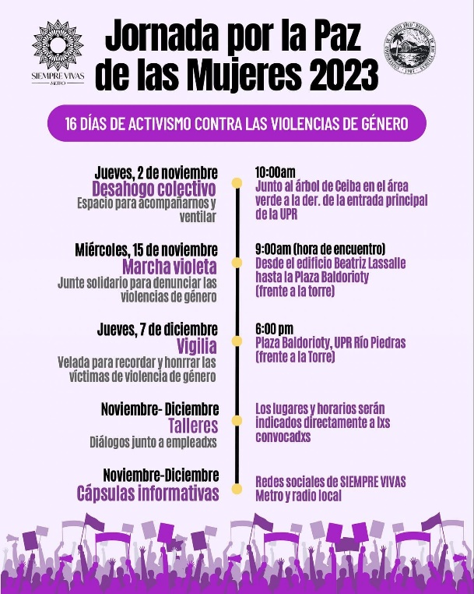
*Special Announcement:
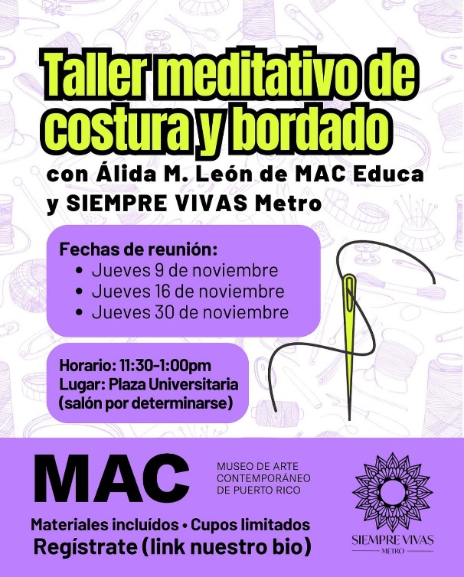

https://www.uprrp.edu/

GHHHHh
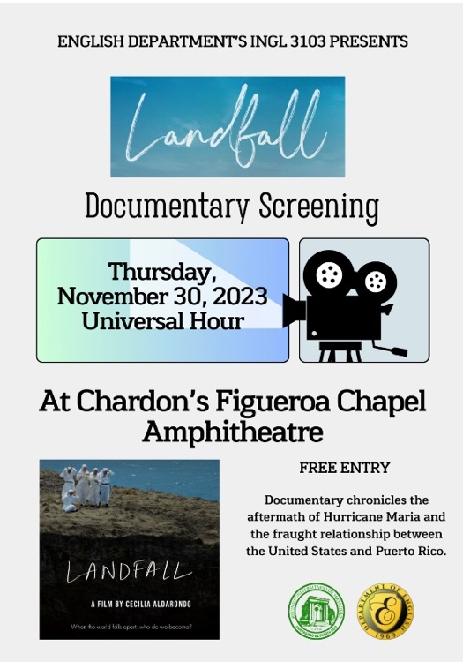
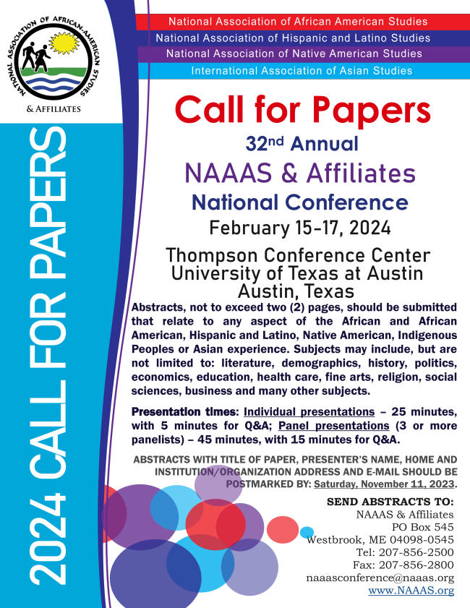

Her Campus Fall 2023
H
He

El Mercado Familiar parte de una iniciativa entre los Departamentos de la Familia y Agricultura para que las comunidades y los beneficiarios del Programa de Asistencia Nutricional (PAN) compren alimentos frescos, cosechados por agricultores de la zona.
Los mercados familiares se realizan para que los consumidores pueden comprar productos locales ya sea con su dinero, con vales provistos por el Departamento de la Familia, o utilizando su tarjeta del Programa de Asistencia Nutricional (PAN).

Jueves, 2 de noviembre
• Sabana Grande – Avenida Orlando López
Dirección Google Maps: oprime aquí
7:00 a.m. – 1:00 p.m.

Viernes, 3 de noviembre
• San Germán – Coliseo Arquelio Torres Ramírez
Dirección Google Maps: oprime aquí
7:00 a.m. – 1:00 p.m.

https://docs.pr.gov/files/Estado/Documentos%20Administrativos/Proclamas/CP882023.pdf

Activities
Monday,  November 6, 2023 | DONAR CON CORAZÓN - Recogido de ropa para la comunidad estudiantil y entidades benéficas.  De 9:00 AM a 3:30 PM, en el vestíbulo de ADEM.  A cargo del grupo Caretakers.  Para más información, favor llamar al 787.464.6786 o  envíe un correo electrónico a: danelilly.bello1@upr.edu. (Caretakers)  ORIENTACIÓN – Oportunidades de internados y empleos en el gobierno federal.  A la 1:30 PM, en CH328.  A cargo de Javier Cuebas.  Para más información, favor enviar un correo electrónico a: ciso@uprm.edu. (CISO)
Tuesday,  November 7, 2023 | ÚLTIMO DÍA - Para someter apelaciones de notas del semestre anterior ante el Comité Institucional de Apelación de Calificaciones. (Calendario Académico)  DONAR CON CORAZÓN - Recogido de ropa para la comunidad estudiantil y entidades benéficas.  De 9:00 AM a 3:30 PM, en el vestíbulo de ADEM.  A cargo del grupo Caretakers.  Para más información, favor llamar al 787.464.6786 o  envíe un correo electrónico a: danelilly.bello1@upr.edu.  TALLER – “Forming and Managing Teams with CATME Team Tools”.  A las 10:30 AM, a través de Teams.  A cargo del Dr. Matthew Ohland.  Registro en: Actividades – Centro de Enriquecimiento Profesional (CEP) (uprm.edu). (CEP)  ASAMBLEA GENERAL DE ESTUDIANTES – Se decretará receso académico si llegan al quorum de 1,073 estudiantes, en o antes de las 11:00 AM.  Para más información, envíe un correo electrónico cge@uprm.edu.  CONCIERTO – Curtain Call.  A las 6:30 PM, en el Anfiteatro de Chardón.  Gratis. (Vida Colegial)  Taller - Leyes Protectoras a la Mujer  de 1:00 p.m. a 2:30 PM, a través de Teams y se estará proyectando simultáneamente en el Anfiteatro AE-242 del Edificio de Administración de Empresas.  A cargo de la Sra. María del Rosario Abrams, de la Oficina de la Procuradora de las Mujeres.  Registro en: https://forms.office.com/r/stiCJuVeCj.  Para más información, favor comunicarse con La Oficina de Enlace con el Personal, adscrita al Decanato de Administración.  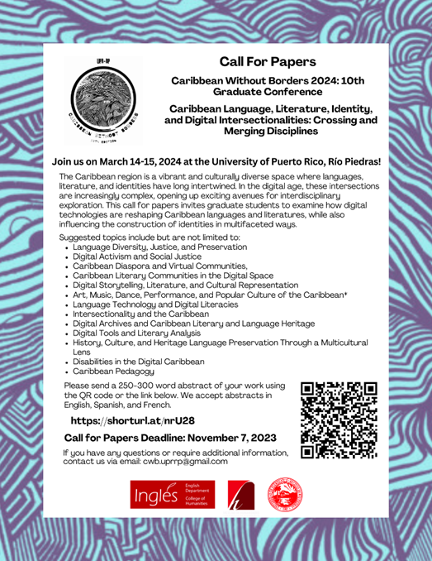
Wednesday,  November 8, 2023 | November 8, 2023 Calendar with Holidays & Count Down - USA (wincalendar.com)
Thursday,  November 9, 2023 | CHARLA – “¿Quién puede estudiar en la UPR?”  Admisión de estudiantes internacionales.  A las 10:30 AM, en C-116 y a través de Teams.  A cargo de la Dra. Frances J. Santiago Torres.  Para reservar, acceda:  Actividades – Centro de Enriquecimiento Profesional (CEP) (uprm.edu) . (CEP)  CONVERSATORIO – “La lucha contra el carbón: A 30 años de la paralización de la planta de carbón en Mayagüez”.  A las 10:30 AM, en el anfiteatro de ININ.  A cargo de la Dra. Julia S. Mignucci y Jorge Fernández.  Para más información, favor enviar un correo electrónico a: tania.lopez1@upr.edu  (Centro Interdisciplinario de Estudios del Litoral, Sea Grant, CoHemis, CISO)  PARADA – Día del Veterano.  A las 10:30 AM, saliendo desde el Edificio ROTC hasta el Coliseo Rafael A. Mangual.  Para más información, favor llamar a la ext. 3382.  (AFROTC)  TERCERA ASAMBLEA – Hope for a Rescue.  A las 10:30 AM, por Google Meets.  Para más información, envíe un correo electrónico a: HopeForaRescue@upr.edu  PRESENTACIÓN DEL POEMARIO – Deseo de verso en la piel, del Dr. Edwin D. Vélez Barreto.  A las 4:30 PM, en el MuSA.  Habrá refrigerios.  Para más información, favor llamar a la ext. 5775. (MUSA)  PRESENTACIÓN DEL LIBRO - Memorias de Sila Calderón. A las 6:00 PM, en AE-242.  Para más información, favor enviar un correo electrónico a: carlos.hernandez15@upr.edu. (CISO)  CONCIERTO – Roy Brown: Regreso al colegio.  A las 7:00 PM, en la Cancha del Antiguo Campo Atlético. Gratis.  (Decanato de Estudiantes)
Friday,  November 10, 2023 | CASA ABIERTA – Colegio 2023.  Desde las 8:00 AM, en la Ave. Laureles / Calle Ceiba.  Para más información, acceda: Casa Abierta – Oficina Admisiones del RUM (uprm.edu) . (Admisiones)  TALLER – “Pandas”  De 1:30 a 3:30 PM, en el GRIC.  A cargo de Guillermo Fidalgo.  Dirigido a profesores, graduados e investigadores.  Se requiere tener conocimiento previo de Python.  Espacios limitados.  Para registro, acceda: Taller de Pandas - UPRM LibCal - University of Puerto Rico, Mayaguez Campus.  (IEEE, GRIC)  CERTIFICACIÓN – Salvavidas.  De 4:00 a 7:00 PM, en el Complejo Natatorio.  A cargo de Yoshua Cintrón.  Costos: $200 / estudiantes; $250 / personas externas; $50 / depósito requerido, no reembolsable.  Para más información, favor llamar al 787.293.7878. (Complejo Natatorio)  FORO COLEGIAL – La revista informativa radial del RUM.  A las 6:30 PM, a través de Radio Universidad en el 88.3 FM en Mayagüez, el 89.7 FM en San Juan y por internet en http://wrtu.pr.  Conducido por la Dra. Mariam Ludim Rosa Vélez, directora de la Oficina de Prensa. (Prensa RUM)
Certificación Número 22-23-108 (Tercera Enmienda) de la Junta Administrativa, relacionada con el Calendario Académico 2023-2024.: 22-23-108 Calendario 2023-2024 Tercera Enmienda.pdf (uprm.edu)

REMINDERS:
THE ENGLISH WRITING CENTER: For more information contact: civis@uprm.edu
"Para su conocimiento, en el enlace encontrarán las Áreas de Estudio del primer semestre 2023-2024."
Please announce to your students that there are computers available for lending. Contact the Student Deanship.

ACADEMIC CALENDAR
22-23-108 Calendario 2023-2024 Tercera Enmienda.pdf (uprm.edu)

UPDATING ENGLISH DEPARTMENT WEBPAGE

Thank you to those who have sent photos and updated their profiles.
Please visit the page and encourage our retired faculty to submit their photo and short bios. https://www.uprm.edu/english/retired-faculty/.

TRAVELING DURING THE SEMESTER
If you plan to travel, please let the Office personnel know so that we can help you with the paperwork. This applies to both faculty and graduate students. Please check your email for the Travel Regulations in English.

If your trip is an official one with institutional funds, please contact Maricarmen Brito.

If you are planning to travel during the Periodo Lectivo, you must fill out this form.

If there are paid expenses or not, you must fill out this form:

Solicitud y Autorización de Orden de Viaje

CLASSROOM UPDATES
CH 005 remains unusable due to the heat. Therefore, classes have been moved to other classrooms on campus.
CH221, 224, 318 & 319: have been converted into virtual classrooms. Training information will follow. CH 125 is in process to be changed into a virtual classroom
CH 325 & 326: Remain closed until further notice (Windows replaced). The Chancellor visited the space with Dean Omar Molina after the windows were replaced.
Graduate Office Space CH 008-013: Floor plans completed; Quotes pending. (Capacity: 17 cubicles and one conference room.)

TROUBLESHOOTING:

Televisions, Computers, or Projectors (Albert’s Office: 787-265-3836)

Please notify Albert Cruz in writing: albert.cruz@upr.edu and cc: rosa.roman3@upr.edu

Physical facilities like doors, locks, fans, windows, offices, lighting, and rodent infestation must be notified in writing: maricarmen.brito@upr.edu, ingles.uprm@upr.edu and cc: rosa.roman3@upr.edu

CARTELERA SEMANAL

Please check for next week’s activities, conferences & other areas of interest in the link below: https://www.uprm.edu/prensa/cartelera-semanal/

LINKS

CERTIFICATION NUMBER 20-21-110, Proposal to schedule ordinary, faculty and departmental meetings.:

Academic Calendar (amended) https://www.uprm.edu/cms/index.php?a=file&fid=20337

PROFESSORS’ MANUAL:

CERTIFICATION NUMBER 16-17-307 AMENDED - Programa Docente, Programación de Matrícula, Ayudantías Graduadas:

CERTIFICATION 16-17-307 JA (JUNTA ADMINISTRATIVA) - Programa Docente, Programación de Matrícula, Ayudantías Graduadas:

