WEEK AT A GLANCE:
September 18 to 22, 2023

ANNOUNCEMENTS:
If your courses are in CH 123, 221, 224, 318, or 319, PLEASE contact Albert on how to use the new equipment. Thank you. Do not disconnect the computers to use your laptop. It will affect the configuration. Next room is CH 125—TBA.
REMEMBER TO TURN OFF THE COMPUTER IF YOUR CLASS IS THE LAST ONE.
Please submit announcements of your activities or accomplishments to ingles.uprm@upr.edu by Thursday at noon. Thank you.
Keys to classrooms and offices have been requested. Please pay attention for an email from Sección de Llaves.
Check your email for information on an English Department Extraordinary Meeting with the Chancelor, Dr. Agustín Rullán on Thursday, October 5, 2023.

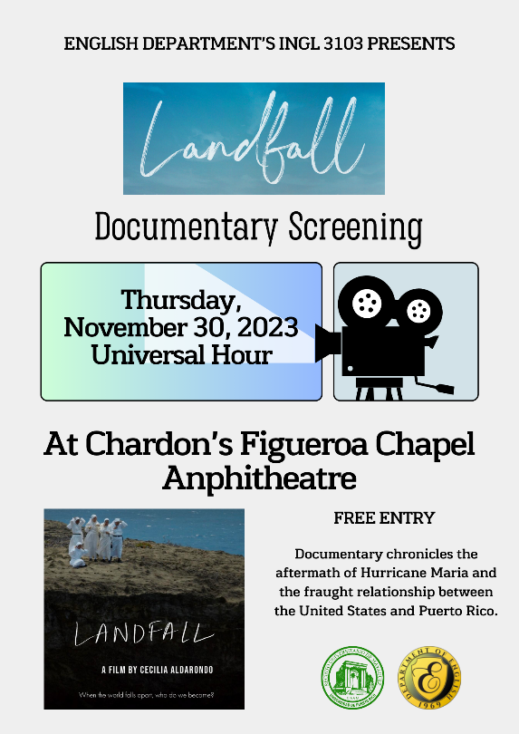
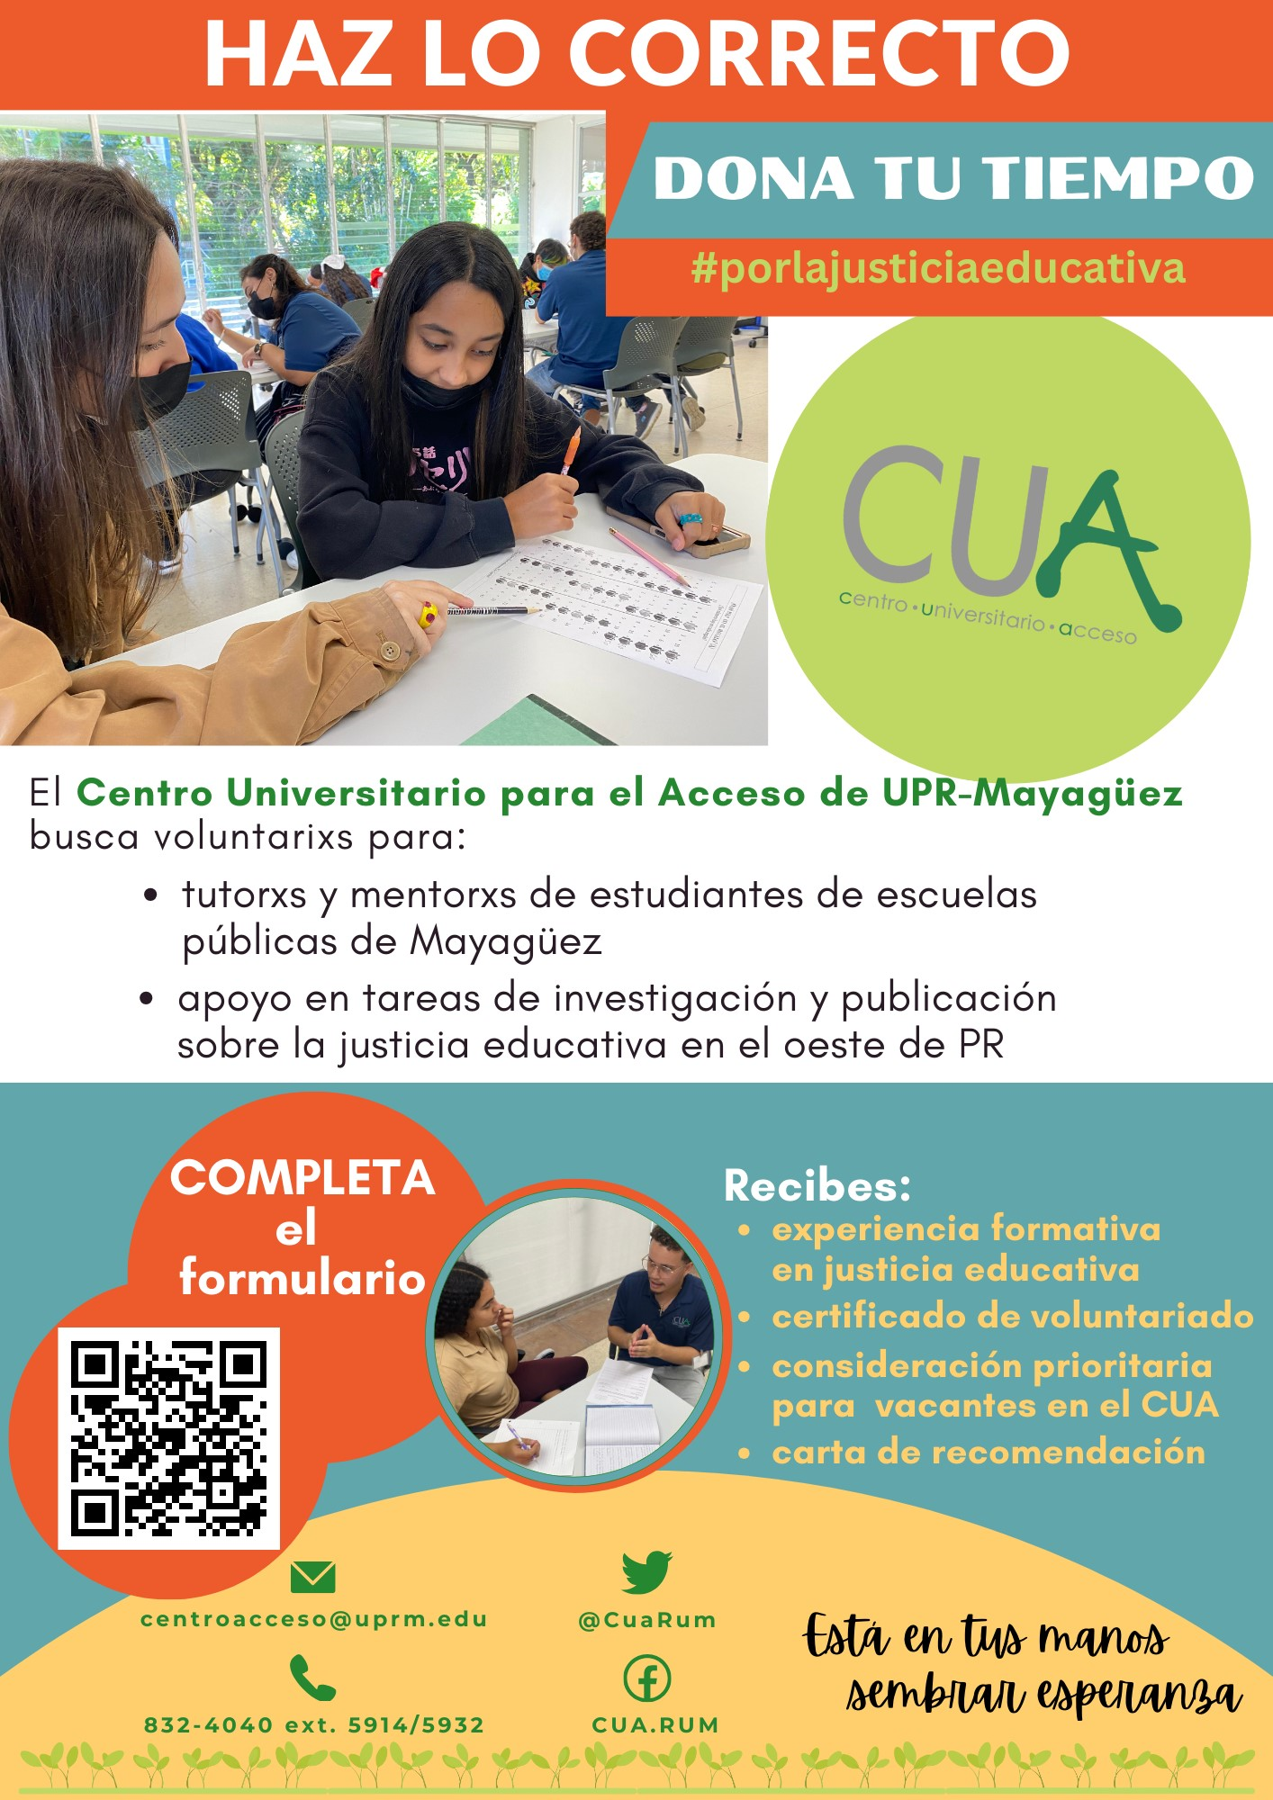

2023 FIRST SEMESTER Dates | Activities
Monday, September 18, 2023 | FERIA DE GRADUADOS - 2023 IVY Plus.  De 10:00 AM a 2:00 PM,  en el Centro de Estudiantes.  (Asuntos Académicos)  PELÍCULA - The Social Dilemma.  A las 6:00 PM,  en ININ-229.  Para más información, favor enviar un correo electrónico a: isos@uprm.edu. (ISOS)
Tuesday, September 19, 2023 | Reunión Ordinaria del Colegio de Artes y Ciencias  a celebrarse de manera híbrida  el martes, 19 de septiembre de 2023, a las 10:30 a.m.  en el Anfiteatro del Edificio Dra. Josefina Torres (Enfermería) y por la plataforma Microsoft Teams Meetings.  PROGRAMA WIC – Si estás embarazada, eres  lactante o posparto, tienes un infante o niño hasta 5  años.  La unidad móvil de 10:00 AM a 2:00 PM.  Interesados, deben subir los siguientes documentos  a la APP de Mi WIC PR: evidencia de ingreso,  residencia física, ID, y vacunas del menor (si aplica).  Para más información, favor llamar a la ext. 2078.  (Calidad de Vida)  COME COLEGIAL – Entrega de cajas de productos  frescos.  De 10:30 AM a 12:00 PM,  en la Placita de Chardón.  Exclusivo para estudiantes matriculados.  Para más información, acceda: bit.ly/3PmdzbS.  FERIA DE SERVICIOS PÚBLICOS – A las 10:30 AM,  en el 3er piso del Centro de Estudiantes.  Para más información, acceda: bit.ly/3PDxILP.  (Calidad de Vida)  TALLER - La telaraña como método educativo  probado, que mejora las discusiones en clases y  apresta a los estudiantes para convertirse en  empleados más competentes.  A las 10:30 AM, a través de Teams.  A cargo del Dr. Santiago Méndez Hernández.  Para más información, acceda: newcep.uprm.edu/. (CEP)
Thursday, September 21, 2023 | MERCADO COLEGIAL – De 8:30 AM a 3:30 PM,  en las Plazas de Chardón.  Espacios limitados.  Para más información, favor llamar a la ext. 3366. (Actividades Sociales y Culturales)  COFFEE AND PASTRY SALE –  De 10:00 AM a 12:00 PM,  en el vestíbulo de Chardón.  (Hope For a Rescue)
SEE AMENDED CALENDAR:
https://www.uprm.edu/cms/index.php?a=file&fid=20337

REMINDERS:
THE ENGLISH WRITING CENTER: For more information contact: civis@uprm.edu
"Para su conocimiento, en el enlace encontrarán las Áreas de Estudio del primer semestre 2023-2024."
Please announce to your students that there are computers available for lending. Contact the Student Deanship.

On Monday, the screening of Romance Tropical, took place in CH121.
This film is the second Spanish sound film ever made. It was entirely filmed in Puerto Rico in 1934. This film was lost for 80 years but was recently found and restored. Cinematheque hosted the film presentation.
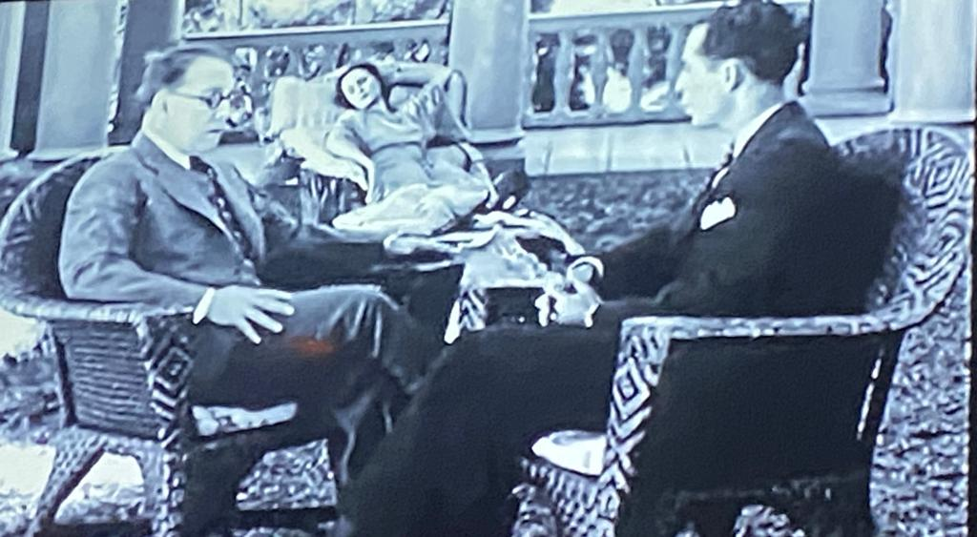

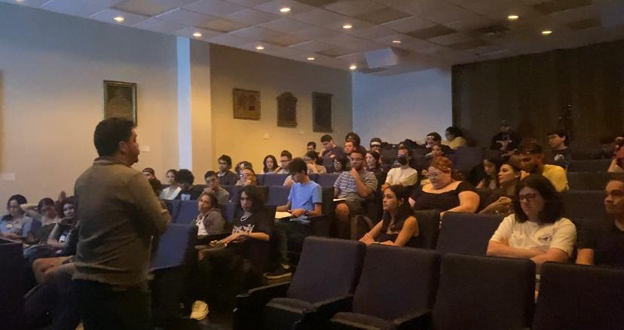

.

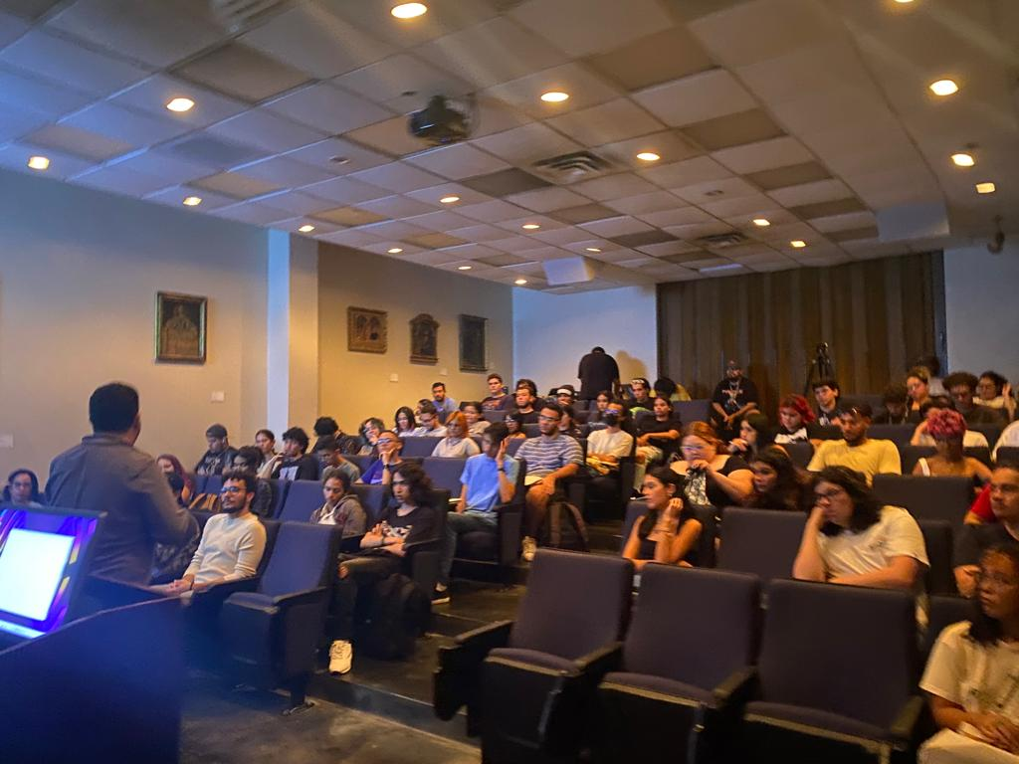

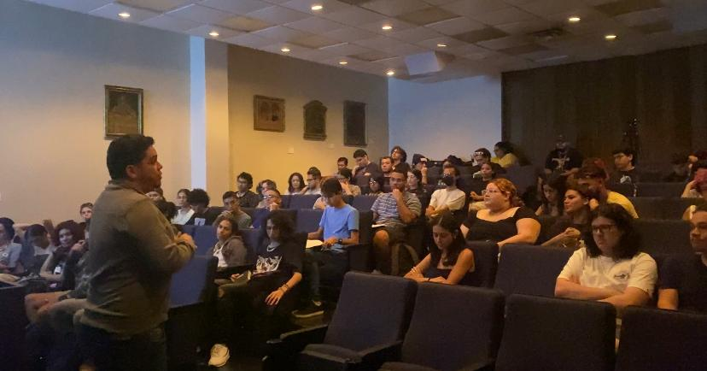

ACADEMIC CALENDAR
ACADEMIC CALENDAR 2023-2024 amended https://www.uprm.edu/cms/index.php?a=file&fid=20337

UPDATING ENGLISH DEPARTMENT WEBPAGE

Thank you to those who have sent photos and updated their profiles.
Please visit the page and encourage our retired faculty to submit their photo and short bios. https://www.uprm.edu/english/retired-faculty/.

TRAVELING DURING THE SEMESTER
If you plan to travel, please let the Office personnel know so that we can help you with the paperwork. This applies to both faculty and graduate students. Please check your email for the Travel Regulations in English.

If your trip is an official one with institutional funds, please contact Maricarmen Brito.

If you are planning to travel during the Periodo Lectivo, you must fill out this form.

If there are paid expenses or not, you must fill out this form:

Solicitud y Autorización de Orden de Viaje

CLASSROOM UPDATES
CH 005 remains unusable due to the heat. Therefore, classes have been moved to other classrooms on campus.
CH221, 224, 318 & 319: have been converted into virtual classrooms. Training information will follow. CH 125 is in process to be changed into a virtual classroom
CH 325 & 326: Remain closed until further notice (Windows replaced). The Chancellor visited the space with Dean Omar Molina after the windows were replaced.
Graduate Office Space CH 008-013: Floor plans completed; Quotes pending. (Capacity: 17 cubicles and one conference room.)

TROUBLESHOOTING:

Televisions, Computers, or Projectors (Albert’s Office: 787-265-3836)

Please notify Albert Cruz in writing: albert.cruz@upr.edu and cc: rosa.roman3@upr.edu

Physical facilities like doors, locks, fans, windows, offices, lighting, and rodent infestation must be notified in writing: maricarmen.brito@upr.edu, ingles.uprm@upr.edu and cc: rosa.roman3@upr.edu

CARTELERA SEMANAL

Please check for next week’s activities, conferences & other areas of interest in the link below: https://www.uprm.edu/prensa/cartelera-semanal/

LINKS

CERTIFICATION NUMBER 20-21-110, Proposal to schedule ordinary, faculty and departmental meetings.:

Academic Calendar (amended) https://www.uprm.edu/cms/index.php?a=file&fid=20337

PROFESSORS’ MANUAL:

CERTIFICATION NUMBER 16-17-307 AMENDED - Programa Docente, Programación de Matrícula, Ayudantias Graduadas:

CERTIFICATION 16-17-307 JA (JUNTA ADMINISTRATIVA) - Programa Docente, Programación de Matrícula, Ayudantias Graduadas:

