WEEK AT A GLANCE:
September 4 to 8, 2023

ANNOUNCEMENTS:
If your courses are in CH 123, 221, 224, 318, or 319, PLEASE contact Albert on how to use the new equipment. Thank you. Do not disconnect the computers to use your laptop. It will affect the configuration. Next room is CH 125—TBA.
REMEMBER TO TURN OFF THE COMPUTER. Some classes after yours might be Hybrid so please make sure to turn everything off especially on Fridays.
Please submit announcements of your activities or accomplishments to ingles.uprm@upr.edu by Thursday at noon. Thank you.
Keys to classrooms and offices have been requested. Please pay attention for an email from Sección de Llaves. If the keys do not open the door, please go back to Sección de Llaves and inform them so they can fix it.

WORKLOAD FORMS
Please submit your information to Maricarmen including all committees you are on as Chair or member.

CALENDAR:

ACADEMIC AFFAIRS & IMPORTANT DATES

2023 FIRST SEMESTER
Dates | Activities
Monday, September 4, 2023 | Holiday – Labor Day
Tuesday, September 5, 2023  Monday | “Día en que se reunirán las clases y laboratorios  correspondientes a un lunes en el calendario regular.”  DECIMA JORNADA SOBRE INTEGRIDAD ACADEMICA  “Habrá actividades virtuales e  híbridas, hasta el viernes en la Biblioteca General.  Para registro y horarios de las actividades, acceda:  bit.ly/3swuNeF. (CEDIBI, GRIC)”
Wednesday, September 6, 2023 | DOCUMENTAL - Todavía estamos aquí: Una historia de cuidado colectivo y resistencia. A las 7:30 PM, en el Taller Libertá en Mayagüez. Realizado por estudiantes del recinto. Para más información, acceda: bit.ly/47NL7Ia. (OHL, INGL, CINE)
Thursday, September 7, 2023 | English Department Meeting (Remote) Link TBA  FREE MINI MARKET – A las 10:30 AM, en el 1er piso de Celis. Recuerda llevar bolsa reusable. (Come Colegial)
Friday, September 8, 2023 | TALLER: VIOLENCIA DOMÉSTICA EN EL AMBIENTE LABORAL  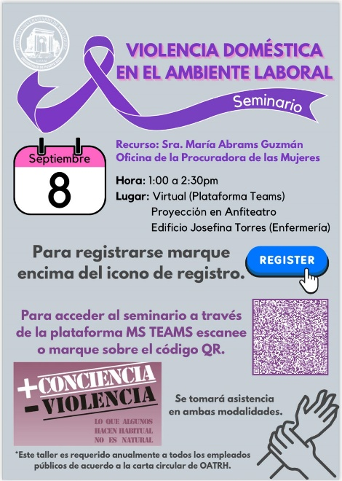

SEE AMENDED CALENDAR:
https://www.uprm.edu/cms/index.php?a=file&fid=20337

REMINDERS:
THE ENGLISH WRITING CENTER: For more information contact: civis@uprm.edu
"Para su conocimiento, en el enlace encontrarán las Áreas de Estudio del primer semestre 2023-2024. "
Please announce to your students that there are computers available for lending. Contact the Student Deanship.

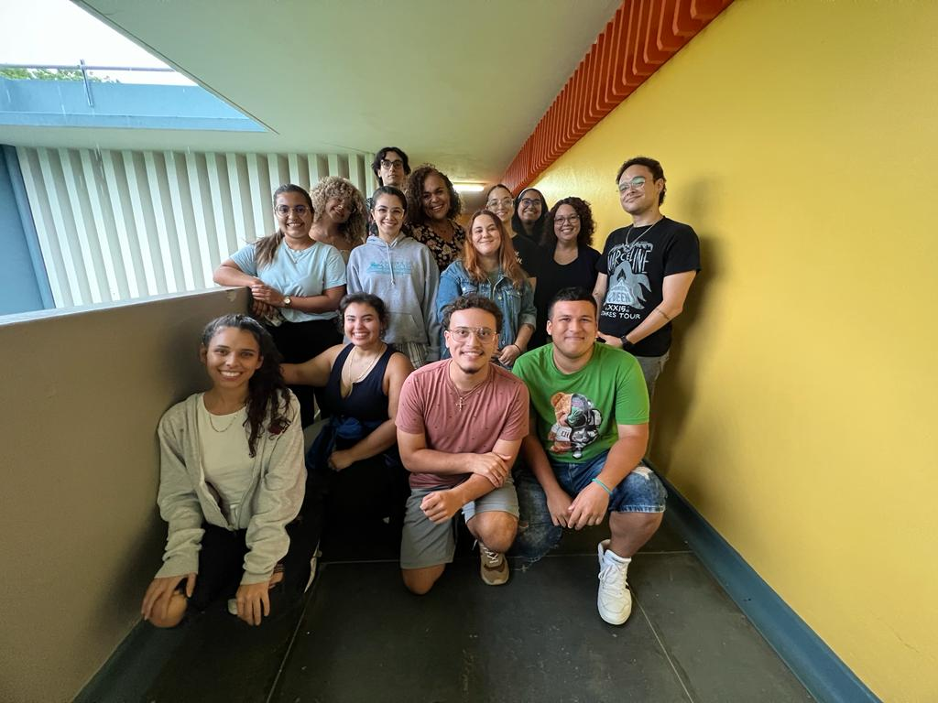
First team meeting for the Center for University Access (CUA), which took place on Friday, August 25, 2023. Dr. Jocelyn Géliga, Dr. Sandra Soto alongside graduate and undergraduate students.

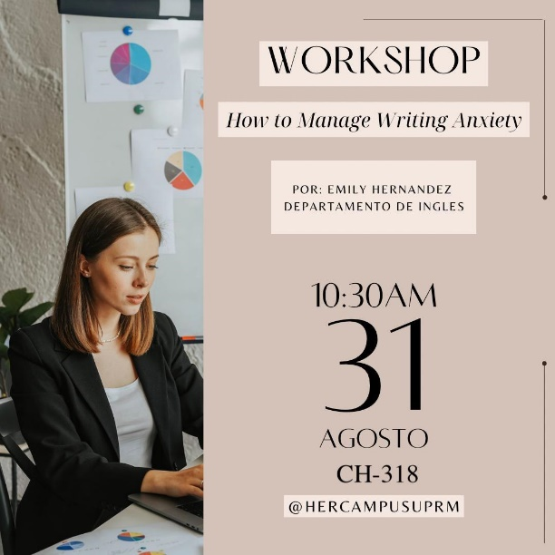
HERCAMPUS sponsored activity with instructor Emily Hernández Giovanetti was a success! Over 50 participants!

More monthly activities to come.

ACADEMIC CALENDAR
ACADEMIC CALENDAR 2023-2024 amended https://www.uprm.edu/cms/index.php?a=file&fid=20337

UPDATING ENGLISH DEPARTMENT WEBPAGE

Thank you to those who have sent photos and updated their profiles.
Please visit the page and encourage our retired faculty to submit their photo and short bios. https://www.uprm.edu/english/retired-faculty/.

TRAVELING DURING THE SEMESTER
If you plan to travel, please let the Office personnel know so that we can help you with the paperwork. This applies to both faculty and graduate students. Please check your email for the Travel Regulations in English.

If your trip is an official one with institutional funds, please contact Maricarmen Brito.

If you are planning to travel during the Periodo Lectivo, you must fill out this form.

If there are paid expenses or not, you must fill out this form:

Solicitud y Autorización de Orden de Viaje

CLASSROOM UPDATES
CH 221, 224, 318 & 319: have been converted into virtual classrooms. Training information will follow. CH 125 is in process to be changed into a virtual classroom
CH 325 & 326: Remain closed until further notice (Windows replaced). The Chancellor visited the space with Dean Omar Molina after the windows were replaced.
Graduate Office Space CH 008-013: Floor plans completed; Quotes pending. (Capacity: 17 cubicles and one conference room.)
CH 005 The breaker system to the air conditioning unit trips. This classroom is unavailable until we find a solution to this. Sorry for the inconvenience.

TROUBLESHOOTING:

Televisions, Computers, or Projectors (Albert’s Office: 787-265-3836)

Please notify Albert Cruz in writing: albert.cruz@upr.edu and cc: rosa.roman3@upr.edu

Physical facilities like doors, locks, fans, windows, offices, lighting, and rodent infestation must be notified in writing: maricarmen.brito@upr.edu, ingles.uprm@upr.edu and cc: rosa.roman3@upr.edu

CARTELERA SEMANAL

Please check for next week’s activities, conferences & other areas of interest in the link below: https://www.uprm.edu/prensa/cartelera-semanal/

LINKS

CERTIFICATION NUMBER 20-21-110, Proposal to schedule ordinary, faculty and departmental meetings.:

Academic Calendar (amended) https://www.uprm.edu/cms/index.php?a=file&fid=20337

PROFESSORS’ MANUAL:

CERTIFICATION NUMBER 16-17-307 AMENDED - Programa Docente, Programación de Matrícula, Ayudantias Graduadas:

CERTIFICATION 16-17-307 JA (JUNTA ADMINISTRATIVA) - Programa Docente, Programación de Matrícula, Ayudantias Graduadas:

