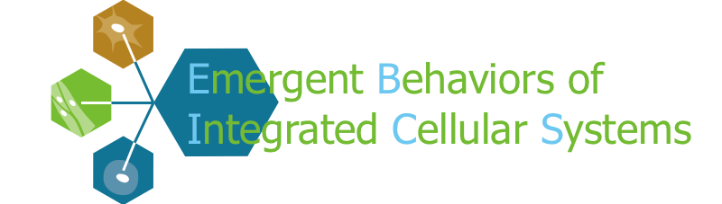
2013 Research Experience for Undergraduate Summer Opportunities
The Center for Emergent Behaviors of Integrated Cellular Systems (EBICS) offers summer research experience for undergraduates (REU) at UIUC, MIT, and Georgia Tech this is a ten week summer program.
Program dates are as follows:
UIUC & Georgia Tech: May 20, 2013 - July 26, 2013
MIT: June 10, 2013 - August 16, 2013
In addition to participating in cutting edge research projects, the program also offers educational activities including seminars, laboratory tours, networking opportunities and professional development.
We encourage students with an interest in biology, bio-engineering, chemistry, physics, materials science, computer science and related field to apply. EBICS strongly encourages applications from underrepresented minority groups and women. US Citizenship or permanent residency is required.
Additional program details, the applicant requirements, and the online application can be found on the web at http://ebics.net/engineering-biological-machines-summer-2013-reu.
EBICS REU application deadline is February 15, 2013.
Benefits
- $4500 Stipend (receive 1st payment during the first week of the program)
- $500 towards travel (advance support is an option)
- Meal allowance
- Paid summer housing
- Hands on experience with-in the graduate labs
- Workshops, GRE prep, collaborations across disciplines
- Networking opportunities with scholars with-in your area of interest
- Professional development activities
- Networking with peers and interdisciplinary opportunities

