Caribbean Journal of Science, Vol. 37, No. 3-4, 259–270, 2001
Copyright 2001 College of Arts and Sciences
University of Puerto Rico, Mayagüez

Seed and Seedling Bank Dynamics in Secondary Forests Following
Hurricane Georges in Puerto Rico

TERESITA LOMASCOLO¹ AND T. MITCHELL AIDE

Biology Department, University of Puerto Rico, P.O. BOX 23360, San Juan, Puerto Rico 00931-3360. ¹Corresponding
author, present address: Laboratorio de Investigaciones Ecológicas de las Yungas (LIEY), Universidad Nacional de
Tucumán, C.C. 34 Yerba Buena (4107), Tucumán, Argentina.
liey@tucbbs.com.ar. tmaide@yahoo.com

ABSTRACT.—This study describes the effect of Hurricane Georges (September, 1998) on the dynamics of
seed and seedling banks in young secondary forests (25 yr) and mature secondary forests (60 yr) in abandoned
pasture lands in Puerto Rico. In eight secondary forest sites, the seed bank was sampled in July 1998
and July 1999, and the seedling bank was sampled in November 1998 and November 1999. We collected data
on number of species and individuals. In the seedling bank, mortality, recruitment and growth rate were
estimated for one year. Hurricane damage was estimated for each site. The data suggest that sites in early
stages of succession receive less damage from hurricane-force winds than older sites. As a consequence, after
a hurricane later stages of succession present high light conditions, which result in high growth rate of
pioneer and non-pioneer species. Although high light conditions may enhance seed germination from the
seed bank, recruitment was low, and most post-hurricane regeneration came from pre-established individuals
in the seedling bank. The recovery of secondary forests is usually studied in reference to time since
abandonment, but this study shows that natural disturbances, particularly hurricanes, can affect the successional
trajectory of secondary forests.

INTRODUCTION

Disturbances play an important role in structuring all natural communities, although ecosystems have different disturbance regimes depending on their geographic location and vegetation type. For example, while fire maintains community structure and function in most shrublands (Christensen, 1985), hurricanes influence plant and animal communities, as well as ecosystem processes in the Caribbean (Tanner et al., 1991).
Hurricanes play a major role in influencing the composition and structure of Caribbean plant communities. Hurricane-force winds cause defoliation, limb loss, and tree uprooting or snapping that change canopy cover and increase light availability in the understory. An additional effect is the pulse of nutrients associated with the enormous deposition of litter (Frangi and Lugo, 1991; Lodge et al., 1991), which may affect seedling bank dynamics (Guzmán-Grajales and Walker, 1991). Human pressure is obviously another important source of disturbance. Most

of the original forest in Puerto Rico was cleared for agriculture, but large tracts were subsequently abandoned, resulting in large areas of secondary forest. The recovery of these forests is usually studied in reference to time since abandonment, although natural disturbances, particularly hurricanes, can affect their normal successional trajectory.
On September 21, 1998, Hurricane Georges struck Puerto Rico, and it was the most destructive hurricane since San Cipriano (1932). Hurricane Hugo (1989) had stronger winds but affected a small portion of the island. Hurricane Georges entered the island from the southeast and traversed it from east to west. Maximum sustained winds were 177 km/h and the eye was 40-48 km wide (National Weather Service Report). Virtually the whole island was affected by hurricane-force winds. At the time of the hurricane, we had been working in the study area for three months studying the recovery of species interactions during secondary succession. The pass of the hurricane gave us the opportunity to study the effect of this natural disturbance in secondary forest dynamics, and we used the pre-

259
260
TERESITA LOMASCOLO AND T. MITCHELL AIDE

viously taken data for the study presented here.
The goal of the present study was to describe the effect of hurricane damage on the dynamics of the seed and seedling banks in young and mature secondary forests in Puerto Rico. The contribution of the seed bank to regeneration can be particularly important in early stages of succession (Garwood, 1989; Bazzaz, 1996). In general, as secondary forests age the seedling/sapling bank becomes more important as a source of regeneration (Bazzaz, 1996). After a hurricane, there is usually low fruit production of tree species (Wunderle, 1999), and seed rain will contribute little to new recruitment. Thus, we expected that the pre-hurricane seed and seedling/sapling banks would be the major sources of regeneration in secondary forests after Hurricane Georges.

STUDY SITES

The study was conducted in secondary forests within the municipalities of Carite, Ciales, Utuado, and Luquillo (Fig. 1). Young secondary forest and mature secondary forest were studied in each location. Young sites had been abandoned for approximately 25 yr and mature sites had been abandoned for approximately 60 yr. The Carite sites (Fig. 1) are in the subtropical moist forest life zone (Ewel and Whitmore, 1973). Young secondary forests are dominated by Spathodea campanulata, Casearia sylvestris and C. guianensis; while mature forests are dominated by Prestoea montana, Inga laurina, and Ocotea leucoxylon

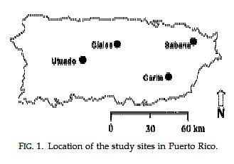

FIG. 1. Location of the study sites in Puerto Rico.

(Pascarella et al., 2000). Ciales (Fig. 1) is in the karst region, within the subtropical moist forest life zone. Young secondary forests are dominated by S. campanulata and Guarea guidonia, while mature forests are dominated by G. guidonia (Rivera and Aide, 1998). Utuado (Fig. 1) is within the subtropical wet forest life zone; its young forests are characterized by the presence of Tabebuia heterophylla and Miconia prasina; while its mature forests are characterized by the presence of G. guidonia and S. campanulata (Marcano-Vega, pers. comm.). Sabana, the site in Luquillo (Fig. 1,) is characterized as subtropical wet forest (Ewel and Whitmore, 1973); its young forests are dominated by Miconia prasina and T. heterophylla, while its mature forests are dominated by Cecropia schreberiana and Dacryodes excelsa (Aide et al., 1996).

MATERIALS AND METHODS

Hurricane damage

To determine damage caused by the hurricane, we estimated basal area of woody debris and canopy openness in each site. In this study, basal area of woody debris is a relative measure to compare the sites, and should not be confused with the common usage of basal area as a forest stand characteristic. We assumed that before Hurricane Georges, woody debris and canopy openness were similar within the young and old sites, and that differences among sites of similar age were due to hurricane damage.
We established three 2 × 30 m transects in each site and measured the diameter of all woody debris (>5 cm diameter) within them. The measurement was made in the widest part of the branch within the transect. Data were analyzed with a Friedman two way nonparametric test. To estimate canopy openness, we counted the number of vegetation layers in the canopy every meter along the transect (Angulo-Sandoval and Aide, 2000). To count vegetation layers, we divided in each point the horizontal space (from 3 m to the highest branch) into segments of approximately 2 m. The number of layers corresponds to the number of

261

SEEDLING DYNAMICS AFTER HURRICANE GEORGES

segments with branches with foliage. These data were analyzed with a log linear model (Systat 8.0. Statistics, 1998). The relationship between woody debris and canopy layers was tested with a Pearson correlation analysis. Although data was taken in March 2000, a year and half after the hurricane, they were expected to reflect the relative differences in wind damage among the sites.

Seed bank

We sampled the seed bank two months before Hurricane Georges (July 1998) and eight months after the hurricane (July 1999). Five 30-m parallel transects, at least 20 m apart, were established in the central area of each site to avoid the edges. We collected soil samples (20 × 20 × 5 cm) every 10 m along each transect for a total of 20 samples per site. Samples were stored in plastic bags and within 24 hr were evenly spread to a depth of 4-5 cm in plastic trays and placed in a greenhouse. The trays were watered daily and germination was recorded weekly for six months. We counted the number of species (species richness) and individuals (abundance) that emerged from the samples. The data for both years were compared using a Wilcoxon Signed Rank test.

Seedling bank

We included in the seedling bank all individuals of woody species 5 to 50 cm in height. Four 28-m parallel transects, at least 20 m apart, were established in the central area of each site to avoid the edges. In November 1998, 1.5 months after Hurricane Georges, all individuals of woody species (5-50 cm tall) were identified and counted in 50 × 50 cm plots every 4 m along the four transects (24 plots per site). Individuals were tagged and height was measured. In November 1999, 14 months after the hurricane, we counted new and surviving individuals and height was re-measured for the surviving individuals. Species richness and abundance in 1998 and 1999 were compared using a Wilcoxon Signed Rank test.
A Pearson correlation analysis was done between

the number of individuals in 1998 and 1999, and we performed a regression analysis between the residuals of this correlation and mean vegetation layers in the canopy. Mortality and recruitment in the young and mature forests were compared using a Mann Whitney test. The relationship between growth rate and canopy layers was tested with a Pearson correlation analysis. To test changes in species composition from 1998 to 1999, we calculated a Jaccard Dissimilarity Index for each site. Indexes from young and mature sites were compared with a Mann Whitney test to determine if changes in species composition were more conspicuous in mature forests.

RESULTS

Hurricane damage

In general, mature forests had higher basal area of woody debris than young forests (Fig. 2), but the Friedman two way nonparametric analysis showed no site or age effect (Friedman statistic = 1, df = 1, p =0.31 for age, and Friedman statistic = 1, df =3, p = 0.49 for site). With the exception of the 60 yr site in Ciales, values for mature forest were >30 m 2 /ha, while the highest value for the young forests was <30 m 2 /ha. An analysis of the vegetation layers in the canopy showed a significant interaction between site and age (G = 81.46, df = 12, p <0.0001, Fig. 3), suggesting that there was no independent effect of site or age. Nevertheless, there was a tendency for young sites to have more observations of three or more vegetation layers than mature forests (Fig. 3), which implies lower illumination in the understory. Mature forests tended to have more gaps (0 canopy layers) than young sites. There was a trend for fewer vegetation layers (more light) in the canopy of sites with more woody debris but the relationship was not significant (r = -0.61 p =0.1, Fig. 4).

Seed bank

In general, young and mature forest sites had more species in the seed bank before
than after Hurricane Georges (Wilcoxon

262
TERESITA LOMASCOLO AND T. MITCHELL AIDE

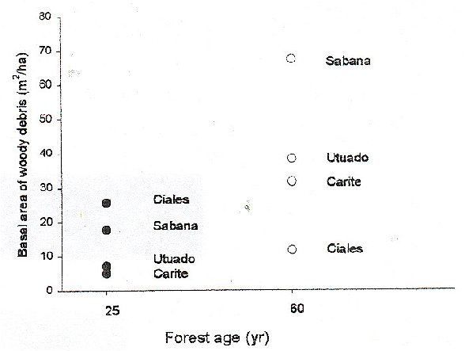

FIG. 2. Total basal area of woody debris ( 5 cm diameter) in the eight sites.

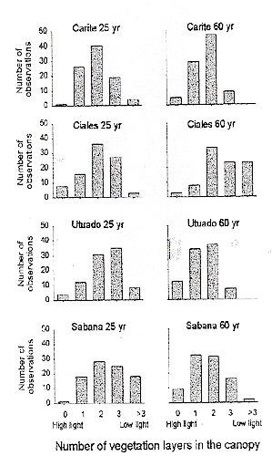

Number of vegetation layers in the canopy

FIG. 3. Distribution of the number of vegetation layers in the canopy in the eight sites.

signed rank test, p = 0.06 for young forests and p = 0.12 for mature forests, (Table 1). Before the hurricane, seeds of C. schreberiana and Solanum
torvum were present in all sites, accounting for
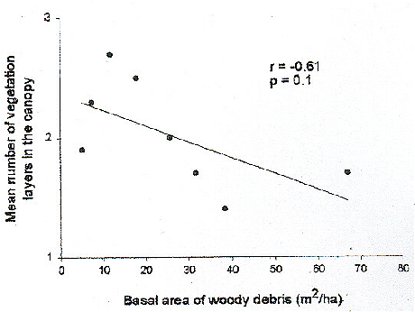

FIG. 4. Relationship between the mean number of vegetation layers in the canopy and basal area of woody debris in each site.

21 % and 20 % of the germinating seeds, respectively (Appendix 1). Other common species in the 1998 census were Zanthoxylum martinicense (20 %) and Piper sp. (14 %). After the hurricane, most seedlings belonged to S. torvum (45 %) and Z. martinicense (11%). The total number of individuals in all sites was marginally greater in 1998 than in 1999 (Wilcoxon Signed Rank test, p = 0.06 and p = 0.06, respectively).

Seedling bank

There was no significant difference in number of species of seedlings between the 1998 and 1999 censuses (Wilcoxon Signed

263
SEEDLING DYNAMICS AFTER HURRICANE GEORGES

TABLE 1. Seed bank data for the eight sites in the 1998 and 1999 censuses.

Species richness Abundance
1998 1999 1998 1999
Carite 25 yr 10 4 97 68
Ciales 25 yr 8 1 75 1
Utuado 25 yr 12 7 198 121
Sabana 25 yr 7 3 26 3
Carite 60 yr 11 11 110 42
Ciales 60 yr 12 8 109 18
Utuado 60 yr 11 5 219 130
Sabana 60 yr 6 1 13 1

Rank test, p = 0.27 for young forests and p= 1.0 for mature forests, Table 2). Although a few species were present in most sites (e.g., G. guidonia and Ocotea sp.), sites usualy had different species assemblages (Appendix 2). There was no significant change in abundance of the seedling bank before and after the hurricane (Wilcoxon Signed Rank test, p = 0.71 for young forests and p = 0.14 for mature forests). Seedling abundance in 1999 was mainly a function of its abundance in 1998 (r 2 = 0.96, p =0.001).
There was no significant relationship between the residuals of the correlation between seedling abundance in 1998 and 1999, and mean canopy layers (r = -0.38, p =0.4), but the high light sites (mean canopy layers <2) tended to have positive residuals and the low light sites (mean canopy layers >2) were very variable. Three of the four mature sites had higher levels of seedling mortality (>55 %), but the difference was not significant (Mann Whitney U test, p =0.08, Table 2). There was no difference in recruitment after the hurricane between the young and mature forest sites (Mann Whitney U test, p = 0.3, Table 2). Although light levels (i.e. vegetation layers) varied among sites, there was no significant relationship between mean vegetation layers and mortality or recruitment (Sperman correlations, r = 0.01, p = 0.9 and r = 0.08, p = 0.8, respectively). Growth rates were very variable in all sites (Fig. 5), but there was a significant relationship between median growth rate and light level in the eight sites (r 2 = 0.5, p = 0.05, Fig. 6). The highest median growth rate (14 cm/yr) occurred in the Utuado 60 yr site, which had the most open canopy. The magnitude of

species composition change between 1998 and 1999 (Jaccard Dissimilarity Index) was similar
for young and mature forests (Mann Whitney test, p = 0.59, Table 2).

DISCUSSION

Hurricane damage in young vs. mature secondary forests

With the exception of the Ciales sites, following the hurricane older forests had more woody debris and a more open canopy than younger forests in the same location. Greater tree height and diameter increase susceptibility to hurricanes (Frangi and Lugo, 1991). The Sabana mature site had the highest amount of woody debris; probably due to the combined effect of Hurricane Georges and Hurricane Hugo in 1989 (Scatena and Larsen, 1991), which affected only this study site. The low amount of woody debris in the Ciales mature site was probably due to its location in a valley surrounded by karst formations (haystack hills or mogotes) which reduced wind speed. The young site in Ciales has
little protection and was dominated by the introduced species Spathodea campanulata, whose branches break easily in strong winds (pers. obs.) and resulted in high levels of damage. Although sites with more woody debris tended to have more open canopies, the relationship was not significant, perhaps because measures were taken 1.5 yr after the passage of the hurricane and canopies had partially recovered (Fernández and Fetcher, 1991).

Regeneration from the seed bank

Species richness and abundance in the seed bank decreased after the hurricane in all sites, regardless of successional status. The reduction of seeds in the soil may be due to high light availability in the understory after the hurricane (Fernández and Fetcher, 1991), which induced seed germination (Garwood, 1989). This could explain the decrease in seeds in sites that suffered severe damage (i.e. Utuado 60 yr, Sabana

264
TERESITA LOMASCOLO AND T. MITCHELL AIDE

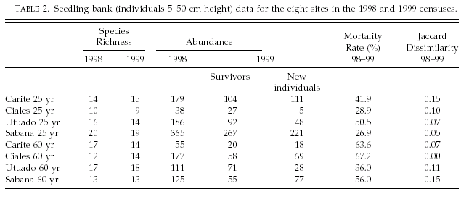

60 yr, Ciales 25 yr), but the same pattern was observed in sites with little damage (i.e. Carite, Utuado, and Sabana young sites). In these cases, the decrease in abundance and species richness in the seed bank may be due to a decrease in seed rain after the hurricane. Strong winds during a hurricane not only remove fruits from trees, but also have a long-term effect, altering patterns of fruiting phenology for several months (Wunderle, 1999). The absence of seeds of C. schreberiana during the posthurricane census suggests a germinating response to increased light availability and a possible delay in the fruiting period of this species. In contrast, S. torvum was very common in both censuses. This pioneer shrub, which suffered low damage during the hurricane because of its low stature and also had high growth rates as a consequence of light availability, probably reproduced soon after the hurricane.

Post hurricane recruitment and
advanced regeneration

We expected that sites with high damage would have more species and more individuals in the 1999 seedling bank census, as a consequence of increased germination from the seed bank in response to increased illumination. However, we found no significant changes in the number of species and individuals in the seedling bank after 14 months with respect to the data collected six weeks after the hurricane.

Apparently, seeds germinated after the hurricane (based on the seed bank data), but herbivory, damage caused by fallen debris, or diseases may have limited recruitment (Martínez-Ramos et al., 1989; Schupp et al., 1989). The number of new individuals in the 1999 census was not related to light availability, but we observed a tendency in which most sites with high light (<2 canopy layers) had more individuals in the 1999 census, although the inverse was not always true for low light sites. An explanation for the lack of correlation could be the high number of individuals of T. heterophylla in the 1999 census with respect to 1998 in the Sabana young site- a low light site (Table 2). This wind-dispersed species produces many seeds and has high germination, but few seedlings survive due to its
high light requirements (pers. obs.). Cecropia schreberiana was abundant in the seed bank samples before the hurricane; during the 1998 census many individuals were observed six weeks after the hurricane but we did not count them because they were <5 cm tall.
Few seedlings survived and reached >5 cm by the 1999 census (14 mo. after the hurricane). A possible explanation for the lack of recruitment of C. schreberiana is that the canopy recovered quickly enough to inhibit the growth of this shade intolerant species. However, Scatena et al. (1996) described high rates of recruitment of C.
schreberiana after Hurricane Hugo. The difference between the two studies may be

265
SEEDLING DYNAMICS AFTER HURRICANE GEORGES

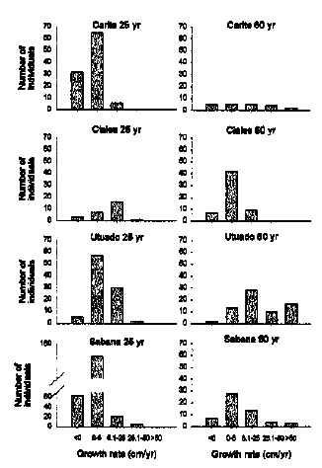

FIG. 5. Number of individuals in each growth rate category (November 1998-November 1999) in the eight sites.

related to differences in forest structure and the size of gaps formed by the hurricanes. Scatena et al. (1996) studied an area of mature forest where large canopy trees were felled during Hurricane Hugo, while in our study most of woody debris consisted of branches rather than entire boles. Advanced regeneration is another source of individuals for colonizing recently opened canopies (Connell, 1989). For example, the most significant effect of the hurricane was the higher median growth rate of individuals in the most disturbed sites. Nevertheless, this was not true for all individuals in high light sites, as many of them had very low growth rates (Fig. 5). Although high light undoubtedly enhances growth, only a fraction of the community can take advantage of this condition. In general, most individuals with high growth rates (90 cm/yr) were pioneer species (e.g., C. schreberiana,
Solanum americanum, S. torvum, and Schefflera

morototoni). In other species, the high variation in growth rates suggests that only a few individuals responded to increased light availability. We expected that the largest change in species composition would occur in the sites that received the greatest damage. This was true in all sites except the young site in Carite (Table 2). This general pattern suggests that hurricanes can lead to a shift in species composition of the seedling bank in highly damaged sites by permitting the growth of seedlings that were inhibited by low light in the understory.

CONCLUSION

Our data suggest that young secondary forests receive less damage from hurricaneforce winds compared to old secondary forests because of their low, uniform canopy, and smaller diameter trees. However, young forests dominated by Spathodea campanulata, an introduced species from tropical Africa and common in secondary forests in Puerto Rico, may receive high damage because the species is not well adapted to hurricane disturbance. Extensive damage to forests dominated by this species may provide opportunity for other species to colonize open areas, thus enhancing species diversity. Older secondary forests received more damage, and increased illumination in these sites resulted in high growth rates of pioneer species (e.g., S. torvum) and some individuals of non-pioneer species (e.g., Ocotea sp.and G. guidonia). High light conditions after the hurricane apparently enhanced seed germination from the seed bank, but recruitment was low, and most of the post-hurricane regeneration in secondary forests came from the growth of individuals pre-established in the seedling bank.

Acknowledgments.—This research was supported by a Master Fellowship provided by Fulbright to the senior author. The University of Puerto Rico and NASAIRA provided additional funds. Cristina Ramos, Josean Martínez, María Fernanda Barberena, Néstor Pérez, Alberto Galindo, Eloisa Lasso, Susan Aragón, Carlos Toledo,

266
TERESITA LOMASCOLO AND T. MITCHELL AIDE

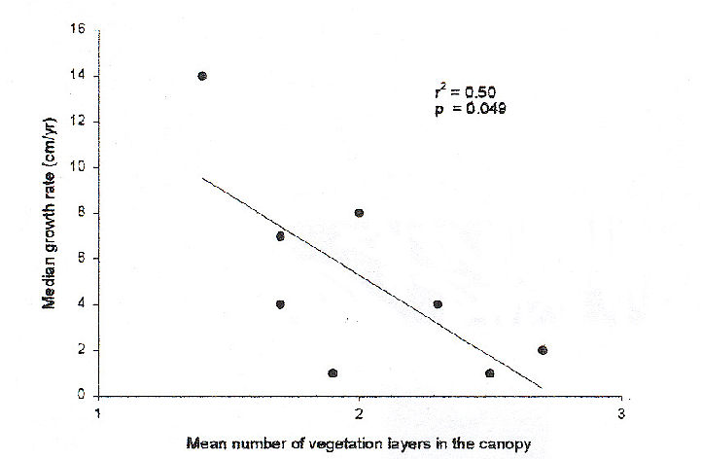

FIG. 6. Relationship between median growth rate (November 1998-November 1999) and mean number of vegetation layers in the canopy.

Tamara Heartsill, Elsie Rivera, and Carla Osorio provided field assistance and helped move the seedling trays before the hurricane. We particularly thank Carlos Trejo for help identifying seedlings. Humberto Marcano, Luis Rivera, and John Pascarella helped to locate the study sites. We also thank Joe Wunderle and Jess Zimmerman for their comments on project design and for improving the manuscript.

LITERATURE CITED

Aide, T. M., J. K. Zimmerman, M. Rosario, and H.
Marcano. 1996. Forest recovery in abandoned
cattle pastures along an elevational gradient in
northeastern Puerto Rico. Biotropica 28: 537-548.
Angulo-Sandoval, P. and T. M. Aide. 2000. Effect of
plant density and light availability on leaf damage
in Manilkara bidentata (Sapotaceae). Journal of
Tropical Ecology 16:447-464.
Bazzaz, F. A. 1996. Plants in changing environments.
Linking physiological, population, and community
ecology. Cambridge University Press, Cambridge,
UK, 320 pp.
Connell, J. H. 1989. Some processes affecting the species
composition in forest gaps. Ecology 70: 560-
562.
Christensen, N. L. 1985. Shrubland fire regimes and
their evolutionary consequences. In S. T. A. Pickett and P.
S. White (eds.), The ecology of natural disturbance
and patch dynamics, pp. 85-100. Academic
Press, San Diego, California.

Ewel, J. J. and J. L. Whitmore. 1973. The ecological life
zones of Puerto Rico and the U.S. Virgin Islands.
Research Paper ITF-18, U.S. Forest Service, 72 pp.

Fernández, D. S. and N. Fetcher. 1991. Changes in light
availability following Hurricane Hugo in a subtropical
montane forest in Puerto Rico. Biotropica 23 (4a): 393-
399.
Frangi, J. L. and A. E. Lugo. 1991. Hurricane damage
to a flood plain forest in the Luquillo mountains of
Puerto Rico. Biotropica 23(4a): 324-335.
Garwood, N. C. 1989. Tropical soil seed banks: a review.
In M. A. Leck, V. T. Parker, and R. L. Simpson (eds.),
Ecology of soil seed banks, pp. 149-209. Academic Press,
New York.
Guzmán-Grajales, S. M. and L. R. Walker. 1991. Differential
seedling responses to litter after Hurricane Hugo in the
Luquillo Experimental Forest, Puerto Rico. Biotropica, 23
(4a): 407-413.
Lodge, D. J., F. N. Scatena, C. E. Asbury, and M. J. Sánchez.
1991. Fine litter fall and related nutrient inputs resulting
from Hurricane Hugo in Subtropical Wet and Lower
Montane rain forests of Puerto Rico. Biotropica 23 (4a):
336-342.
Martínez-Ramos, M., E. Alvarez-Buylla, and J. Sarukhán.
1989. Tree demography and gap dynamics in a tropical
rain forest. Ecology 70: 555-558.
Pascarella, J. B., T. M. Aide, M. I. Serrano, and J. K.
Zimmerman. 2000. Land-use history and forest
regenerarion in the Cayey mountains, Puerto Rico.
Ecosystems. 3:217-228.
Rivera, L. W. and T. M. Aide. 1998. Forest recovery in the
karst region of Puerto Rico. Forest Ecology and
Management 108: 63-75.
Scatena, F. N. and M. V. Larsen. 1991. Physical aspects of
Hurricane Hugo in Puerto Rico. Biotropica 23(4a): 317-
323.

267
SEEDLING DYNAMICS AFTER HURRICANE GEORGES

Scatena, F. N., S. Moya, C. Estrada, and J. D. Chinea. 1996.
he first five years in the reorganization of aboveground
biomass and nutrient use following Hurricane Hugo in the
Bisley Experimental watersheds, Luquillo Experimental
Forest, Puerto Rico. Biotropica 28 (4a): 424-440.
Schupp, E. W., H. F. Howe, C. K. Augspurger, and D. Levey.
1989. Arrival and survival in tropical treefall gaps.
Ecology 70: 562-564.
Systat 8.0. Statistics. 1998. SPSS Inc., Chicago, Illinois, U.S.
Tanner, E. V. J., V. Kapos, and J. R. Healey. 1991. Hurricane
effects on forest ecosystems in the Caribbean. Biotropica
23 (4a): 513-521.
Wunderle, Jr. J. M. 1999. Pre- and post-hurricane fruit
availability: implications for Puerto Rican parrots
in the Luquillo mountains. Caribbean Journal of
Science 35 (3-4): 249-264.

Appendix I. Species abundance (number of individuals) in the seed bank in each site for the 1998 and 1999 censuses (blank spaces = no seedlings)

